

SMART+ Survey Report

AAH,01-2024,LilianK
Isiolo County, Kenya
January 2024
Full Smart
Validated
Funded by: Agency Name(s)
Assessment Coordinated by: Saida Abdirahman (Isiolo County Nutrition Coordinator), Lilian Kaindi (Survey Manager- ACF)
Technically Supported by: Nutrition Information Technical Working Group, AAH Canada








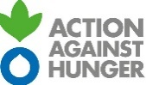


Acknowledgements
The successful completion of the Isiolo County 2024 SMART survey was made possible through the collaborative efforts of various partners, under the leadership of the County Department of Health (CDH). This survey has provided invaluable insights into the health, nutrition, and food security status of the population in the County, serving as a cornerstone for informing and evaluating programming in nutrition-specific and sensitive sectors.
We extend our sincere appreciation to the local authorities, community leaders, and stakeholders whose support and cooperation were integral to facilitating the survey process and ensuring its accuracy and relevance. The dedication and commitment of the survey team, who worked tirelessly to collect and analyze the data, are also deserving of recognition.
Furthermore, we express our profound gratitude to the following organizations for their unwavering commitment and substantial support:
- UNICEF
- USAID Nawiri
- WFP
- Action Against Hunger
- Kenya Red Cross Society
- We World, Feed the Future
- ACDI/VOCA
Their contributions, both logistical and financial, played a crucial role in facilitating the smooth execution of the survey.
Lastly, we would like to extend our gratitude to all individuals involved in the preparation and review of this report. Their expertise and efforts have greatly contributed to the quality and clarity of the findings presented herein.

Table of contents
1. Acknowledgements 2
2. Acronyms 5
3. Executive Summary 6
4. Introduction 7
4.1. Organization 7
4.2. Background Information 7
4.3. Survey Type 8
4.4. Survey Timing 8
4.5. Type of Setting 9
4.6. Survey Location 9
4.7. Excluded Areas (if applicable) 9
5. Survey Goal and Objectives 9
5.1. Survey Goal and Primary Objective 9
5.2. Specific Survey Objectives 9
5.3. Survey Justification 10
6. Methodology 10
6.1. Survey Design 10
7. Indicators: Definition, Calculations, and Interpretation 13
7.1. Overview of Indicators 13
7.2. Anthropometric Indicators 14
7.3. Other Indicators as Applicable (Immunization, Infant and Young Child Feeding, etc.) 16
8. Questionnaire 16
9. Limitations 16
10. Survey Findings 16
10.1. Survey Sample 16
10.2. Data Quality 17
10.3. Prevalence of Acute Malnutrition 18
10.4. Prevalence of Chronic Malnutrition 22
10.5. Prevalence of Underweight 24
10.6. Prevalence of Overweight 26
10.7. Other Indicator Results 27
11. Discussion 38
11.1. Nutritional Status of the Province 38
11.2. Determinants of Malnutrition 38
12. Conclusion and Recommendations 39
Annexes 40
Annex 1 - Cluster Selection 40
Annex 2 - Standardization Test Results 50
Annex 3 - Plausibility Check 54
Annex 4 - Integrated Questionnaire 54
Annex 5 - Map of Area 54
References 55

List of tables
Table -: Summary of Findings 8
Table -: Sample Size Calculation of Anthropometry 12
Table -: Sample Size Calculation of Mortality 13
Table -: Standardized Integrated SMART Indicators 15
Table -: MUAC cut off points for children 6-59 months 17
Table -: Cut off points for the WHZ index expressed in Z-score, WHO Standards 17
Table -: Cut off points for the HAZ index expressed in Z-score, WHO Standards 17
Table -: Cut off points for WAZ Index expressed in Z-scores, WHO Standards 17
Table -: Proportion of Household and Child Sample Achieved (Anthropometry Data) 18
Table -: Distribution of age and sex among children 6-59 months (SMART exclusions) 19
Table -: Mean Z-scores, Design Effects, Missing and Out-of-Range Data of Anthropometric Indicators among Children 6-59 months (SMART exclusions) 19
Table -: Prevalence of Acute Malnutrition by WHZ (and/or oedema) by Severity and Sex among Children 6-59 months (SMART exclusions), WHO 2006 Reference 20
Table -: Prevalence of Acute Malnutrition per WHZ and/or Oedema by Severity and Age Group (SMART exclusions) 20
Table -: Distribution of Severe Acute Malnutrition per Oedema among Children 6-59 months (SMART exclusions) 21
Table -: Prevalence of acute malnutrition based on MUAC cut off's (and/or oedema) and by sex 22
Table -: Prevalence of Acute Malnutrition per MUAC and/or Oedema by Severity and Age Group 22
Table -: Prevalence of combined GAM and SAM based on WHZ and MUAC cut off's (and/or oedema) and by sex 23
Table -: Detailed number for combined GAM and SAM 23
Table -: Prevalence of Chronic Malnutrition by HAZ by Severity and Sex among Children 6-59 months (SMART exclusions) 25
Table -: Prevalence of Chronic Malnutrition per HAZ by Severity and Age Group (SMART exclusions) 25
Table -: Prevalence of Underweight by WAZ by Severity and Sex among Children 6-59 months (SMART exclusions), WHO 2006 Reference 27
Table -: Prevalence of Underweight per WAZ by Severity and Age Group (SMART exclusions) 27
Table -: Prevalence of overweight based on weight for height cut off's and by sex (no oedema) (SMART exclusions) 29
Table -: Prevalence of overweight by age, based on weight for height (no oedema) (SMART exclusions) 29
Table -: Average FCS* 30
Table -: Food Consumption Score by Category 30
Table -: Negative coping strategies used by the surveyed population over the past 7 days 30
Table -: Average rCSI 31
Table -: Median Household Hunger Score 31
Table -: Household Hunger Score by Category 31
Table -: Water Quality (Adapt list to water sources available in the local setting) 32
Table -: Proportion of households practicing household water treatment 32
Table -: Household Water Treatment Use 33
Table -: Safe Excreta Disposal (Adapt list to sanitation facilities available in the local setting) 34
Table -: Access to a Specific Handwashing Device 34
Table -: Handwashing devices 34
Table -: Water Quantity 1: Amount of Litres of Water Used Per Person Per Day 35
Table -: Proportion of households that use domestic water collected from protected/treated sources with protected containers only 35
Table -: Vitamin A supplementation coverage for children aged 6-59 months within the past 6 months 35
Table -: Deworming coverage for children aged 12-59 months within the past 6 months* 36
Table -: Measles vaccination coverage for children aged 9-59 months 36
Table -: Measles vaccination coverage for children aged 9-23 months 36
Table -: Prevalence of ARI symptoms, fever and diarrhoea in the two weeks preceding the survey for children aged 6-59 months 37
Table -: ORS and zinc use during diarrhoea episode for children aged 6-59 months 37
Table -: Treatment for ARI symptoms, fever and diarrhoea for children aged 6-59 months 37
Table -: Prevalence of Infant and Young Child Feeding Practices Indicators 38
Table -: Physiological status for women aged 15-49 39
Table -: Women's Age (all women aged 15-49) 39
Table -: Prevalence of MUAC Malnutrition in Non-Pregnant, Non-Lactating Women (Aged 15-49) 39
Table -: Prevalence of MUAC Malnutrition in Pregnant Women and Lactating Women with an Infant Less Than 6 Months 40
Table -: Prevalence of GAM by WHZ Comparing the 0-59 Month to the 6-59 Month Sample 40
Table -: Bias and Technical Error of Measurement (TEM) Results for Weight 52
Table -: Bias and Technical Error of Measurement (TEM) Results for Height 53
Table -: Bias and Technical Error of Measurement (TEM) Results for MUAC 54
Table -: Anthropometry Data Quality Snapshot 56

List of figures
Figure -: Distribution of WHZ Sample Compared to the WHO 2006 WHZ Reference Curve 21
Figure -: Mean WHZ by Age Group 22
Figure -: Pie Chart of Proportion of Children with GAM by Indicator 24
Figure -: Pie Chart of Proportion of Children with SAM by Indicator 25
Figure -: Distribution of HAZ Sample Compared to the WHO 2006 WHZ Reference Curve 26
Figure -: Mean HAZ by Age Group 27
Figure -: Distribution of WAZ Sample Compared to the WHO 2006 WHZ Reference Curve 28
Figure -: Mean WAZ by Age Group 29
Figure -: Survey Area 57

Acronyms
AAH | Action Against Hunger
ANC | Ante Natal Care
ARI | Acute Respiratory Infections
ASAL | Arid and Semi-Arid Lands
BFCI | Baby Friendly Community Initiative
BHA | Bureau of Humanitarian Assistance
CDH | County Director of Health
CECM | County Executive Committee Member
CHMT | County Health Management Team
CHS | Community Health Services
CHP | Community Health Promoter
CI | Confidence interval
CIDP | County Integrated Development Plan
CLTS | Community led Total Sanitation
cm | Centimeter
CNC | County Nutrition Coordinator
CO | Chief Officer
CSB | Corn Soy Blend
CSG | County Steering Group
CSI | Coping strategy index
DD | Dietary Diversity
DEFF | Design Effect
EWS | Early Warning System
FCS | Food Consumption Score
GAM | Global Acute Malnutrition
GoK | Government of Kenya
HAZ | Height for Age -Z score
HDD | Household Dietary Diversity
HH | Household
HHS | Household Hunger Scale
HSNP | Hunger Safety Net Program
IDP | Internally Displace Persons
IFAS | Iron and Folic Acid Supplements
IMAM | Integrated Management of Acute Malnutrition
IPC | Integrated Food Security Phase Classification
IYCF | Infant and Young Child Feeding
KEMSA | Kenya Medical Supplies Agency
KFSSG | Kenya Food Security Steering Group
KHIS | Kenya Health Information System
KNBS | Kenya National Bureau of statistics
KRCS | Kenya Red Cross Society
LMIS | Logistics Management Information System
LPPPD | Litres Per Person Per Day
LRA | Long Rains Assessment
MAM | Moderate Acute malnutrition
MCH | Mother Child Booklet
MDD | Minimum Dietary Diversity
MDD-W | Minimum Dietary Diversity for Women
MIYCN | Maternal and Infant Young Child Nutrition
MOH | Ministry of Health
MUAC | Mid Upper Arm Circumference
NDMA | National Drought Management Authority
NGO | Non-governmental Organization
NITWG | Nutrition Information Technical Working Group
ODK | Open Data Kit
ORS | Oral Rehydration Solution
OTP | Outpatient Therapeutic Programme
PLW | Pregnant and Lactating Women
PPS | Probability proportional to size
RC | Reserve cluster
rCSI | Reduced Coping Strategy Index
RUSF | Ready To use Supplementary food
RUTF | Ready to Use Therapeutic Food
SAM | Severe Acute Malnutrition
SCHMT | Sub-County Health Management Team
SCNO | Sub County Nutrition Officer
SD | Standard Deviation
SFP | Supplementary Feeding Programme
SMART | Standardized Monitoring and Assessment of Relief and Transitions
SPSS | Statistical package for Social Sciences
U5 | Under Five Years Old
UN | United Nations
UNICEF | United Nations Children’s Fund
USAID | United States Agency for International Development
WASH | Water Sanitation and Hygiene
WAZ | Weight for Age -Z score
WFP | World Food Programme
WHO | World Health Organization
WHO-GS | World Health Organisation Growth Standards
WHZ | Weight for Height -Z score
WRA | Women of Reproductive Age

Executive Summary
The Isiolo County SMART survey, conducted using the innovative SMART+ infrastructure, was led by the Isiolo County Health Department's nutrition division, in collaboration with various stakeholders within the county. Technical support was provided by Action Against Hunger SMART team, ensuring the seamless implementation of the survey. It was conducted from late January to early February 2024, aligning with the short dry/lean season.
The primary goal was to determine the prevalence of acute malnutrition among children 6-59 months and women of reproductive age. Specific objectives included assessing malnutrition prevalence, morbidities, health-seeking behavior, and coverage of interventions.
The survey employed a cross-sectional and descriptive design, utilizing cluster sampling methodology to ensure representation across Isiolo County, Kenya. Sample size calculations were based on SMART+ infrastructure, considering expected prevalence, design effect, and desired precision. Two-stage cluster sampling was implemented, with clusters selected using Probability Proportional to Size (PPS) and households randomly chosen within clusters. Sampling procedures were facilitated by the SMART+ mobile application, with teams comprising one team leader and two enumerators conducting data collection. A five-day comprehensive training, overseen by supervisors from Action Against Hunger, Isiolo County, and SMART+ managers, equipped team members with necessary skills. Quality control mechanisms, including real-time data submission and standardization tests, ensured accuracy and consistency in data collection. Data analysis utilized SMART+ platform for certain indicators and SPSS version 23 for comprehensive assessment.
The survey findings showed a Global Acute Malnutrition (GAM) prevalence in children 6-59 months of 13.7%, indicating a persistently high burden of malnutrition in Isiolo County. A summary of nutritional status and other indicators in the survey is presented in Table 3-1.
.
Table 3-1: Summary of Findings
Indicator | Denominator (N) | Numerator (n) | Result  (95% CI)
GAM prevalence among children 6-59 months per WHZ < -2SD* | 444 | 61 | 13.7%  (10.6%, 17.7%)
SAM prevalence among children 6-59 months per WHZ < -3SD | 444 | 10 | 2.3%  (1.3%, 4.0%)
GAM prevalence among children 6-59 months per MUAC <125 mm | 447 | 8 | 1.8%  (0.8%, 3.7%)
SAM prevalence among children 6-59 months per MUAC <115 mm | 447 | 3 | 0.7%  (0.2%, 2.1%)
Combined GAM prevalence among children 6-59 months per WHZ < -2SD or MUAC <125 mm | 447 | 63 | 14.1%  (10.9%, 18.0%)
Combined SAM prevalence among children 6-59 months per WHZ < -3SD or MUAC <115 mm | 447 | 12 | 2.7%  (1.6%, 4.4%)
Stunting among children 6-59 months per HAZ < -2SD | 435 | 74 | 17.0%  (12.9%, 22.1%)
Severe stunting among children 6-59 months per HAZ < -3SD | 435 | 13 | 3.0%  (1.8%, 4.8%)
Underweight among children 6-59 months per WAZ < -2SD | 444 | 82 | 18.5%  (15.1%, 22.4%)
Severe underweight among children 6-59 months per WAZ < -3SD | 444 | 18 | 4.1%  (2.4%, 6.7%)
Vitamin A supplementation coverage for children aged 6-59 months within the past 6 months | 450 | 359 | 79.8%  (71.0%, 86.4%)
Deworming coverage for children aged 12-59 months within the past 6 months | 375 | 264 | 70.4%  (61.5%, 78.0%)
Measles vaccination coverage for children aged 9-59 months | 434 | 406 | 93.5%  (89.8%, 96.0%)
Measles vaccination coverage for children aged 9-23 months | 131 | 120 | 91.6%  (85.8%, 95.2%)
Prevalence of ARI symptoms in the two weeks preceding the survey for children aged 6-59 months | 449 | 26 | 5.8%  (3.4%, 9.6%)
Prevalence of fever in the two weeks preceding the survey for children aged 6-59 months | 450 | 164 | 36.4%  (29.5%, 44.0%)
Prevalence of diarrhoea in the two weeks preceding the survey for children aged 6-59 months | 449 | 91 | 20.3%  (15.0%, 26.8%)
Infant and Young Child Feeding (IYCF)
Early initiation to breastfeeding (0-23 months) | 172 | 167 | 97.1%  (92.1%, 99.0%)
Exclusive breastfeeding under 6 months (0-5 months) | 25 | 20 | 80.0%  (56.6%, 92.5%)
Continued breastfeeding (12-23 months) | 99 | 72 | 72.7%  (62.9%, 80.8%)
Introduction of solid, semi-solid or soft foods (6-8 months | 16 | 11 | 68.8%  (38.4%, 88.6%)
Minimum dietary diversity (6-23 months) | 147 | 57 | 38.8%  (29.0%, 49.5%)
Minimum meal frequency (6-23 months) | 147 | 48 | 32.7%  (24.7%, 41.8%)
Minimum acceptable diet (6-23 months) | 147 | 20 | 13.6%  (8.2%, 21.8%)
Food Security
HHs with Acceptable FCS | 621 | 366 | 58.9%  (51.7%, 65.8%)
HHs with little or no hunger | 623 | 350 | 56.2%  (48.3%, 63.8%)
Water Sanitation and Hygiene (WASH)
HHs with improved sanitation facilities | 624 | 336 | 53.8%  (43.2%, 64.2%)
Proportion of Households getting water from protected/treated water sources | 623 | 432 | 69.3%  (55.1%, 80.7%)
Additional Indicators in the survey
Percentage of mothers of children aged 0–23 months who received or purchased any iron, iron syrup or iron-folate tablets during the most recent pregnancy while pregnant with their youngest child | 201 | 181 | 90%  (85.9%, 94.2%)
Percentage of mothers of children aged 0–23 months who received or iron, iron syrup or iron-folate tablets and took them for 90 or more days while pregnant with their youngest child | 201 | 114 | 56.7%  (49.9%, 63.6%)
Percentage of mothers of children aged 0–23 months who were attended during their last pregnancy that led to a live birth at least once by skilled health personnel | 201 | 193 | 96.0%  (93.3%, 98.7%)
Percentage of women consuming foods from five or more or the MDD-W ten food groups | 561 | 157 | 28.0%  (49.9%, 63.6%)

In conclusion, the survey findings highlight the critical need for urgent and targeted interventions to address the persistently high levels of malnutrition in Isiolo County. With a Global Acute Malnutrition (GAM) prevalence of 13.7% and Severe Acute Malnutrition (SAM) prevalence of 2.3% among children aged 6-59 months, the situation demands immediate attention. Despite efforts to improve nutrition outcomes, the prevalence of acute malnutrition remains concerning, emphasizing the necessity for sustained and comprehensive interventions. It is imperative to prioritize recommendations aimed at enhancing food security, improving healthcare access, and promoting optimal infant and young child feeding practices. Additionally, continuous nutrition monitoring and periodic surveys are crucial to assess the effectiveness of interventions and guide future strategies.

Introduction

Organization
The Isiolo County SMART survey, utilizing the innovative SMART+ infrastructure, was spearheaded by the Isiolo County Health Department (CHD), specifically through its nutrition department, in close collaboration with various stakeholders within the county. Facilitating the technical aspects of the survey was the SMART team at Action Against Hunger Canada, renowned for their expertise in piloting the SMART+ infrastructure. Technical support was provided by the Regional SMART+ Managers team to ensure the seamless implementation of the survey.

Background Information
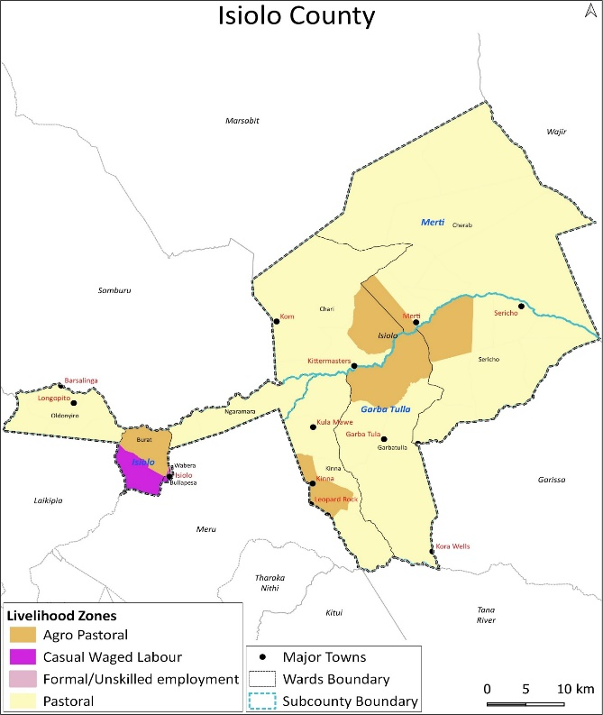
Isiolo County is in the Upper Eastern Region of Kenya. It borders seven Counties and covers an area of 25,350.6 KM². The Estimated population is 283,139 with a population density of 11 people per KM² and an annual growth rate of 1.45%. The county has four livelihood zones namely; Pastoral, Casual and Waged Labour, Agro-Pastoral and Formal/Unskilled employment with human population per livelihood zone being 50.1, 24.8, 15.7 and 9.3 percent respectively. The county consists of three (3) sub-counties namely Isiolo, Garbatulla and Merti.

Survey Area
Most of the land in the Isiolo County is flat low lying plain. The plains rise gradually from an altitude of about 200 M above sea level at Lorian swamp, 300M above sea level at Merti Plateau; 1100 M above the sea level at Isiolo town with the highest point occurring at Oldonyiro-Labarishereki at 2019M above sea level.
Isiolo County, predominantly arid and semi-arid, features vast low-lying plains covering 80% of its land, primarily utilized for grazing, while agro pastoralism is practiced in limited areas. The county is categorized into three agro-ecological zones: semi-arid (5%), arid (30%), and very arid (65%). Rainfall is seasonal, with short rains from October to December, peaking in November, and long rains from March to May, peaking in April. Rainfall distribution varies based on topography, with higher areas near Mount Kenya and Nyambene Hills receiving 500-670mm annually, contrasting with less than 300mm in the drier eastern and northern parts. High temperatures, averaging 29 degrees Celsius annually, and abundant sunshine, exceeding nine hours daily, highlight the county's solar energy potential. Monsoon winds, peaking in July to August, offer significant opportunities for wind energy.

Survey Population
The population of Isiolo County predominantly comprises Oromo-speaking Borana and Sakuye communities, alongside Turkana, Samburu, Meru, Somali, and various immigrant groups from other regions. Despite its expansive size, Isiolo County maintains a relatively low population density compared to the national average, with Isiolo Sub-County standing out as the most populous area. The target population for this survey was the general population residing within the county.

Humanitarian Assistance
Humanitarian assistance in Isiolo County involved various sectors, benefiting a significant number of individuals. Social protection measures, including cash transfers and emergency responses, aided over 13,000 vulnerable households. Water sector projects, such as constructing and rehabilitating water systems, served thousands of individuals, with approximately 8,000 people gaining access to improved water sources. Livestock sector support impacted over 2,000 households through disease surveillance and capacity-building programs. Health and nutrition interventions, catering to acute malnutrition and medical outreaches, reached over 7,500 households and covered approximately 27 villages. These interventions were implemented by various agencies such as NDMA, WFP, ACF, CRS-Kenya Rapid+, MID-P, Vet Department, MOH, and other implementing partners.
Severe flooding in November 2023, driven by heavy rains, disrupted transportation routes, severely impacting market access in Isiolo County.

Health and Safety Situation Update
Overall, there were no major disease outbreaks reported, with cases of diarrhea being the most prevalent, largely attributed to poor hygiene practices resulting from limited access to clean water for household use. Among the general population, acute upper respiratory tract infections (URTI), malaria, skin diseases, and urinary tract infections were the most common ailments. However, among children under the age of five, diarrhea, upper respiratory tract infections, pneumonia, intestinal worms, and skin diseases were prevalent.

Survey Type
The survey type used was a Full SMART survey. Anthropometry served as the core indicator, with all three anthropometric indices evaluated. Additionally, the survey encompassed various supplementary indicators, including Infant and Young Child Feeding (IYCF), Food Security, Water, Sanitation, and Health (WASH), Maternal Nutrition Status, Child morbidity and treatment seeking, Vitamin A supplementation, Deworming, and immunization. This holistic assessment allowed for a thorough understanding of the health and nutrition status of the surveyed population, enabling targeted interventions and program planning to address identified needs effectively.

Survey Timing
The SMART survey took place from late January to early February 2024, specifically from January 27th to February 1st (Six Days). Notably, this was the short dry/lean season according to the Isiolo County seasonal calendar as shown in the table below.
- Short rains start  - Short dry spell  - Reduced milk yields  - Migration to dry season area  - Land preparation |  |  | - Migration to wet grazing areas  - Long rains  - High Calving Rate  - Milk Yields Increase  - Reduced pasture/water stress (Normal Scenario) |  |  |  | - Long rains harvest  - A long dry spell  - Increased distances to water and pasture  - Reduced water levels  Kidding (Sept)  - Community/HH coping measures taken |  |  |  | - Short rains season  Planting in Agro-pastoral  - Migration from dry season area  - Increased milk yield  - Reduced pasture/water stress (Normal scenario)
Jan | Feb | Mar |  | Apr | May | Jun | Jul | Aug | Sept | Oct |  | Nov | Dec

Type of Setting
This survey took place in both Rural & Urban of Isiolo County, Kenya

Survey Location
The survey took place in Isiolo County, Kenya, which is one of the nation's 47 counties and is administratively situated within the Upper Eastern region.

Excluded Areas
The decision to exclude certain areas from data collection within the survey location, namely Gotu, El Dera, and Komu, was primarily attributed to security concerns.

Survey Goal and Objectives

Survey Goal and Primary Objective
The overall objective of this survey was to determine the prevalence of acute malnutrition among children 6-59 months and women of reproductive age 15 – 49 years in Isiolo County.

Specific Survey Objectives
Outline the specific objectives of your survey.
- To estimate the prevalence of acute and chronic malnutrition in children aged 6 to 59 months.
- To estimate the prevalence of identified morbidities (diarrhea, fever, cough etc.) in children 6‐59months in the last two weeks prior to the survey dates.
- To determine the coverage for zinc supplementation and use of ORS in children 6-59 months during episodes of diarrhea.
- To assess immunization coverage (BCG, OPV1 & OPV3 for children 6 to 59 months, and Measles 1 & Measles 2 for children 9 to 59 months)
- To estimate the coverage of deworming (12-59 months) and Vitamin A supplementation (6-59 months).
- To assess the health seeking behavior of mothers/caretakers of children 6-59 months.
- To assess IYCF practices
- To assess malnutrition status of Women of Reproductive Age by MUAC
- To estimate coverage of iron and folic acid supplementation during pregnancy among Women of Reproductive Age
- To collect contextual information on possible causes of malnutrition such as household food security, water, hygiene and sanitation (WASH) practices
- Develop recommendations based on survey findings.

Survey Justification
The survey was justified by several factors: Firstly, recent assessments had projected an improvement in acute food insecurity from Crisis (IPC phase 3) to IPC phase 2, but KHIS data indicated a concerning increase in diarrheal diseases between August and November 2023, peaking in November with a 55% rise compared to the previous year. Despite ongoing health, nutrition, WASH, and food security interventions by the County Government and partners, the survey was deemed necessary to assess progress and inform further response actions and program adjustments. Additionally, as the survey aligned with seasonality trends, it provided crucial insights into the current health and nutrition situation in Isiolo County, facilitating the assessment of the impact of the 2023 short rains season and informing the subsequent short rain assessment scheduled for January-February 2024.

Methodology

Survey Design
The survey was designed as a cross-sectional and descriptive study, adopting the Standardized Monitoring and Assessment on Relief and Transition (SMART) methodology. It utilized a quantitative approach to gather data.

Sample Size
The survey employed cluster sampling methodology, chosen for its efficiency in covering large geographic areas and populations while ensuring representation. The sample size for anthropometry was determined using the SMART+ infrastructure. To calculate the sample size, assumptions for expected prevalence, expected design effect (DEFF), and required precision were made. The expected prevalence of acute malnutrition (Global Acute Malnutrition) was considered, along with the desired level of precision to achieve reasonable accuracy. If the number of children was converted into the number of households, this was likely done by estimating the average number of children per household within the target population.
Sample sizes were adjusted for potential non-response, with a predicted non-response rate factored into the calculations. This adjustment aimed to ensure that the final sample size would still provide statistically significant results even if some households or individuals did not participate in the survey.
In cluster sampling, the decision on the number of clusters and households per cluster was based on achieving the desired level of precision while considering logistical constraints and resources available for data collection. The number of clusters was determined to adequately represent the geographic and demographic diversity of the survey area, while the number of households per cluster was set to balance precision with operational feasibility.
Table 6-2: Sample Size Calculation of Anthropometry
Parameters for Anthropometry | Value | Assumption and Source
Estimated prevalence of GAM (%) | 15.4% | January 2023 SMART survey showed a GAM rate of 15.4 % (12.5 - 18.9 95% C.I.)  From contextual, (NDMA EWS) and mass screening data it’s showing an improving situation due to improved biophysical, production, access and utilization indicators.  Increase in of diarrhea cases in Nov 2023 might have negated the impact of the rains hence the situation likely to remain the same.
Desired precision | ± 4.00 | This is adjusted in consideration of the rule of thumb based on the anticipated prevalence.
Design effect (DEFF) | 1.20 | Adjusted from the previous design effect of 1.02 in the county. This is sufficient to cater for any heterogeneity.
Children to be included | 409.00
Average household (HH) size | 5.00 | Based on the previous SMART Survey (2023) and KNBS Projections (2022)
% Children 6-59 months | 14.4% | From KNBS Analytical report on population projections volume XVI.
% Non-response rate | 3.0% | Based on previous assessments ongoing community mobilization is expected to create awareness of upcoming assessment. Little non-response anticipated
Households to be included | 650.00 | Minimum sample size-Households to be surveyed.

Sampling Method
The survey employed a two-stage cluster sampling approach. In the first stage, clusters were selected using Probability Proportional to Size (PPS), ensuring that larger clusters, representing more densely populated areas, had a higher probability of selection. In the second stage, households were randomly selected within the chosen clusters to participate in the survey.

Second Stage Sampling Method
In the second stage of sampling, simple random sampling was utilized across all selected clusters. This approach was deemed optimal as households within the survey areas were not geometrically ordered. The use of a Random Number Generator (RNG) embedded in the SMART+ mobile application (SMART Collect) facilitated effective and efficient sampling procedures.

Sampling Procedure – Cluster Sampling
To execute cluster sampling effectively, a comprehensive list of all villages in the county with their respective population sizes was obtained, incorporating household mapping data from 2023 conducted by the Department of Health. Areas to be excluded, such as Gotu, El Dera, and Komu, were omitted from the final sampling frame. The updated sampling frame was then uploaded into the SMART+ application for the selection of 47 clusters and 5 reserve clusters. The reserve clusters were designated to be activated if a minimum of 10% of the sampled clusters were missed or if 80% of the children sample was not achieved. Within each cluster, Simple Random Sampling (SRS) was employed to select 14 households for visitation. All eligible children within the selected households were included in the survey, with age ranges of 6-59 months for anthropometry and 0-23 months for the IYCF survey. In households lacking eligible children, data pertaining to the household were collected. Empty households or those with absent children were revisited at least once before the teams departed the cluster. The outcomes for each selected household were documented in the cluster control form, facilitating easy supervision and follow-up of the survey.

Training, Team Composition, and Supervision
A total of eight teams were deployed for the survey, each comprising One team leader and Two enumerators. Team leaders were selected from senior staff of the Isiolo County Government, while enumerators were current or former nutrition officers/volunteers from the Isiolo County Health Department. Additionally, supervisors from organizations including Action Against Hunger, Isiolo County, and the newly trained SMART+ managers were involved in overseeing the teams.
All team members, including supervisors, underwent a comprehensive five-day training facilitated by the SMART team with support from the Nutrition Information Technical Working Group (NITWG). The training covered various aspects such as sampling methods, anthropometric measurements, interviewing techniques, identification and referral of malnourished children, utilization of the SMART collect tool, and understanding of survey components. A standardization test and pre-test were conducted during the training to ensure consistency and accuracy in data collection.
Supervisors were actively engaged throughout the data collection period, with each team receiving dedicated supervision and support for every cluster visited. To enhance data quality, supervisors collectively provided feedback to the teams before each day's data collection. Additionally, meticulous planning of team movements ensured coordinated supervision logistics and cohesive progress across all teams.

Data Analysis
The survey data collection relied on the SMART collect mobile application, seamlessly integrated into the SMART+ infrastructure. Data entry was conducted by survey enumerators directly into the SMART+ platform, enabling real-time submission of data at the conclusion of each day's collection. The platform facilitated efficient data management, offering survey managers insights into data quality, sample size attainment, and overall completeness. Quality control mechanisms, including SMART flags for anthropometric analysis, were incorporated to detect and address outliers, such as those exceeding +/- 3 standard deviations from the observed WHZ mean. While some indicators such anthropometric, Food security, IYCF analysis were conducted within the platform, additional indicators were analyzed using SPSS version 23 for comprehensive data assessment.

Indicators: Definition, Calculations, and Interpretation

Overview of Indicators
The Table below provides an overview of the indicators used in the survey.
Table 7-4: Standardized Integrated SMART Indicators
Indicator | Target Population
Household Indicators
Food Security
Food Consumption Score (FCS) | Total population
Reduced Coping Strategy Index (rCSI) | Total population
Household Hunger Scale (HHS) | Total population
WASH
Access to safe/improved water for drinking and cooking | Total population
Household water treatment | Total population
Access to improved sanitation facilities | Total population
Access to a handwashing system | Total population
Access to sufficient quantity of water | Total population
Child Indicators
Anthropometry | 6-59 months
Vitamin A supplementation coverage | 6-59 months
Deworming coverage | 12-59 months
Measles vaccination coverage | 9-59 months
Episode of ARI, and care-seeking for children with ARI | 6-59 months
Episode of diarrhoea, care-seeking for children with diarrhoea, and use of ORS and Zinc during an episode of diarrhoea | 6-59 months
Episode of fever and care-seeking for children with fever | 6-59 months
IYCF (EvBF, EIBF, EBF2D, EBF, MixMF, CBF, ISSSF, MDD, MMF, MMFF, MAD, EFF, SwB, UFC, ZVF, BoF) | 0-24 months
Women Indicators
Anthropometry (MUAC) | 15-49 years

Anthropometric Indicators
Anthropometric indicators were evaluated utilizing age, weight (kg), height/length (cm), MUAC (mm), and bilateral pitting edema. The measurement procedures and criteria are detailed as follows:

- Age: Recorded as the date of birth (day/month/year) when documented on official papers like, health or baptismal cards and birth certificates. In cases of missing documentation, a local event calendar was used to estimate birth month and year.
- Weight (in kg): Children's weight was measured without clothing to the nearest 100g (0.1 kg) using a SECA electronic scale. Standing children were weighed directly on the scale, while non-standing children were measured using the double-weighing method.
- Height/Length (in cm): A measuring board was employed to measure bareheaded and barefoot children with a precision of 0.1 cm. Children under 2 years were measured lying down (length), while those over 2 years were measured standing up (height). Two measurers, assisted by caregivers, conducted each measurement.
- Mid-Upper Arm Circumference (MUAC): Measured using a flexible non-elastic tape midway between the tip of the acromion and the tip of the olecranon of the left arm, with the arm hanging freely. MUAC measurements were recorded in millimeters (nearest millimeter precision).
- Bilateral Pitting Edema: Evaluated by applying moderate thumb pressure on both feet for three seconds. The presence of edema was confirmed if a shallow pit remained after releasing pressure. Only children with bilateral edema were considered positive for nutritional edema, with all cases confirmed by supervisors.
Table 7-5: MUAC cut off points for children 6-59 months
Nutritional Status | Definition
No malnutrition | 125 mm > MUAC
Global Acute Malnutrition (GAM) | 125 mm ≤ MUAC
Moderate Acute Malnutrition (MAM) | 115 mm ≤ MUAC < 125 mm
Severe Acute Malnutrition (SAM) | MUAC < 115 mm

Table 7-6: Cut off points for the WHZ index expressed in Z-score, WHO Standards
Nutritional Status | Definition
No undernutrition | WHZ ≥ -2 and no oedema
Global Acute Malnutrition (GAM) | WHZ < -2 or bilateral oedema (or both)
Moderate Acute Malnutrition (MAM) | (-3 ≤ WHZ < -2) and absence of bilateral oedema
Severe Acute Malnutrition (SAM) | WHZ < -3 or bilateral oedema (or both)
Overweight | WHZ > 2 and no oedema
Moderate overweight | (2 < WHZ ≤ 3) and no oedema
Severe overweight | WHZ ≥ 3 and no oedema

Table 7-7: Cut off points for the HAZ index expressed in Z-score, WHO Standards
Nutritional Status | Definition
Not stunted | HAZ ≥ -2
Stunted | HAZ < -2
Moderate stunting | -3 ≤ HAZ < -2
Severe stunting | HAZ < -3

Table 7-8: Cut off points for WAZ Index expressed in Z-scores, WHO Standards
Nutritional Status | Definition
Not underweight | WHZ ≥ -2
Global underweight | WAZ < -2
Moderate underweight | -3 ≤ WAZ < -2
Severe underweight | WAZ < -3

Other Indicators
    - Food Security
Additional indicators relating to food security are described below:
- Reduced Coping Strategy Index (rCSI) measures how households manage or cope with reduced access to food. It is a proxy indicator for household food access and helps to identify those who are most vulnerable in a community. The index is based on a list of five coping strategies applied seven days before the survey and combines the frequency of each and their severity. Each coping strategy has a universal severity weight applied to the final score. Though there is no universal threshold for the rCSI, the higher the rCSI, the more severe the coping is in a household. A score of 0-15 indicates low coping, 16-40 indicates medium coping, and 41 or higher indicates high coping.
- Household Hunger Scale (HHS) is a food deprivation scale. It is built around three questions about the perceptions of a household on varying degrees of hunger by the number of times a household has experienced hunger within the 30 days prior to the survey. A score of 0-1 is categorized as “little or no hunger”, a score of 2-3 as “moderate hunger”, and a score of 4-6 as “severe hunger”.
- Food Consumption Score (FCS) is a composite score of dietary diversity, food frequency, and relative nutritional importance of different food groups. It represents households' dietary diversity and nutrient intake. The FCS was calculated from households’ consumption of different food groups in the seven days before the survey. A score of 0-21 was considered poor, 21.5-35 is borderline and above 35 is an acceptable consumption score.

    - Water, sanitation, and hygiene
Additional indicators relating to water, sanitation, and hygiene (WASH) are detailed below:
- Access to safe/improved water for drinking and cooking: Percentage of households with access to safe/improved water for drinking and cooking.
- Household water treatment: Percentage of households practicing household water treatment.
- Access to improved sanitation facilities: Percentage of households with access to improved sanitation facilities.
- Access to a handwashing system: Percentage of households with access to a handwashing system.
- Access to a sufficient quantity of water: Average # L/p/d of domestic water collected at the household level, from protected/treated sources with containers of any type as well as with protected containers only. The percentage of households that use domestic water collected from protected/treated sources with protected containers only.
- Distance to Water Source: Average time required to reach the water source, collect water (including queuing), and bring it back home.
- Hand Washing Practice: Percentage of respondents who washed their hands with soap or ash before or after their last critical occasion.

    - Child health and nutrition
Additional indicators relating to infant and young child feeding (IYCF) practices are outlined below:
- Breastfeeding indicators
  - Ever breastfed: Percentage of children born in the last 24 months who were ever breastfed.
  - Early initiation: Percentage of children born in the last 24 months who were put to the breast within one hour of birth.
  - Exclusively breastfed for the first 2 days after birth: Percentage of children born in the last 24 months who were fed exclusively with breast milk for the first two days after birth.
  - Exclusive breastfeeding under 6 months: Percentage of infants 0–5 months of age who were fed exclusively with breast milk during the previous day.
  - Mixed milk feeding under 6 months: Percentage of infants 0–5 months of age who were fed formula and/or animal milk in addition to breast milk during the previous day.
  - Continued breastfeeding: Percentage of children 12–23 months of age who were fed breast milk during the previous day.

- Complementary feeding indicators
  - Introduction of solid, semi-solid or soft foods: Percentage of infants 6–8 months of age who consumed solid, semisolid, or soft foods during the previous day.
  - Minimum dietary diversity: Percentage of children 6–23 months of age who consumed foods and beverages from at least five out of eight defined food groups during the previous day.
  - Minimum meal frequency: Percentage of children 6–23 months of age who consumed solid, semi-solid or soft foods (but also including milk feeds for non-breastfed children) at least the minimum number of times during the previous day.
  - Minimum milk feeding frequency for non-breastfed children: Percentage of non-breastfed children 6–23 months of age who consumed at least two milk feeds during the previous day.
  - Minimum acceptable diet: Percentage of children 6–23 months of age who consumed a minimum acceptable diet during the previous day.
  - Egg and/or flesh food consumption: Percentage of children 6–23 months of age who consumed egg and/or flesh food during the previous day.
  - Sweet beverage consumption: Percentage of children 6–23 months of age who consumed a sweet beverage during the previous day.
  - Unhealthy food consumption: Percentage of children 6–23 months of age who consumed selected sentinel unhealthy foods during the previous day.
  - Zero vegetable or fruit consumption: Percentage of children 6–23 months of age who did not consume any vegetables or fruits during the previous day.

- Other IYCF indicators
- Bottle feeding percentage of children 0–23 months of age who were fed from a bottle with a nipple during the previous day.

Additional indicators relating to child health are outlined below:
- Vitamin A supplementation coverage: Percentage of children aged 6-59 months who received a vitamin A capsule in the six months preceding the survey.
- Deworming coverage: Percentage of children aged 12-59 months who were given deworming medication in the six months preceding the survey.
- Measles vaccination coverage: Percentage of children aged 9-59 months who received measles vaccination.
- Episode of diarrhoea, care-seeking for children with diarrhoea, and use of ORS and Zinc during an episode of diarrhoea: Percentage of children aged 6-59 months who had a diarrhoea episode in the two weeks preceding the survey. Additional measures include the percentage of caregivers who sought treatment for the child and the percentage of children who received ORS, zinc, or both during the episode.
- Episode of fever and care-seeking for children with fever: Percentage of children aged 6-59 months who had a fever episode in the two weeks preceding the survey and the percentage of caregivers who sought treatment for the child.
- Episode of acute respiratory infection (ARI), and care-seeking for children with ARI: Percentage of children aged 6-59 months who had an ARI episode in the two weeks preceding the survey and the percentage of caregivers who sought treatment for the child.

Maternal Health and Nutrition
- Antenatal care (1+ visit): Percentage of mothers of children aged 0-23 months who received one or more antenatal care visits from a skilled health provider.
- Antenatal care (4+ visits): Percentage of mothers of children aged 0-23 months who had four or more antenatal visits while pregnant with their youngest child.
- Iron Folic Acid (possession): Percentage of mothers of children aged 0-23 months who received or purchased any iron tablets during the most recent pregnancy while pregnant with their youngest child.
- Iron Folic Acid (consumption): Percentage of mothers of children aged 0-23 months who took iron tablets for 90 or more days while pregnant with their youngest child.
- Minimum dietary diversity (MDD)-women: Percentage of women consuming foods from five or more or the MDD-W ten food groups

Social Demographic Information
- Main Occupation of Household Head: The primary type of work or employment undertaken by the individual designated as the head of the household.
- Household's Main Current Source of Income: The primary source of financial support for the household.
- Enrolment in Cash Transfer Program: Whether the household is currently receiving financial assistance through any cash transfer or welfare program.
- Children Who Have Come to Live with You Recently: The number of children who have joined the household recently, either through birth, adoption, or relocation.
- Highest Level of Education: The highest level of formal education attained by adults in the household.
- School Enrolment: The current enrolment status of children of school-going age within the household, indicating whether they are currently attending school.

Questionnaire
The survey questionnaire was initially prepared in written English but was administered in local languages based on the cluster's location. Given Isiolo County's diverse population with over six tribes, team composition was carefully planned to include members fluent in the local languages. During training, significant time was dedicated to familiarizing the teams with the questionnaire to ensure accurate administration. Pretesting of the questionnaire was conducted in four nearby villages that were not included in the sampling, and feedback gathered from this exercise was shared with the survey teams to further refine the questionnaire.

Limitations
Due to security concerns, some areas within Isiolo County were excluded from the survey, potentially leading to a lack of representation of certain populations. Additionally, the survey relied on self-reported data, which could be subject to recall bias or inaccuracies.

Survey Findings

Survey Sample
The survey aimed to include 409 children for the anthropometric survey, drawn from 650 households spread across 47 clusters. Ultimately, the survey successfully reached 449 children, exceeding the target, which represented 109.8% coverage, and covered 624 households, accounting for 94.8% of the intended sample size, across all 47 clusters, achieving full coverage. Analysis revealed that out of all households surveyed, 388 had children under five years old, indicating that approximately 62.2% of households in the surveyed areas had children in this age group.
Table 10-9: Proportion of Household and Child Sample Achieved (Anthropometry Data)
Indicator | Value
Number of clusters planned | 47
Number of clusters surveyed | 47
% clusters of planned | 100%
Number of households planned | 650.1
Number of households surveyed | 624
% households of planned | 94.8%
Number of children planned | 408.6
Number of children surveyed | 449
% children of planned | 109.8%
Among the 449 children surveyed for anthropometry, 234 were boys and 215 were girls, resulting in a sex ratio of 1:09. This shows equal representation of boys and girls in the survey, supported by a p-value of 0.370. Additionally, the age ratio between children aged 6-29 months and those aged 30-59 months was 0.86, closely aligning with the expected value of 0.85. Hence, both younger and older children were equally represented in the survey.
Table 10-10: Distribution of age and sex among children 6-59 months (SMART exclusions)
Age (Months) | Boys |  | Girls |  | Total |  | Ratio
Age (Months) | n | % | n | % | n | % | Boy:Girl
6 to 17 | 45.0 | 19.2% | 53.0 | 24.7% | 98.0 | 21.8% | 0.85
18 to 29 | 57.0 | 24.4% | 52.0 | 24.2% | 109.0 | 24.3% | 1.10
30 to 41 | 57.0 | 24.4% | 48.0 | 22.3% | 105.0 | 23.4% | 1.19
42 to 53 | 53.0 | 22.6% | 43.0 | 20.0% | 96.0 | 21.4% | 1.23
54 to 59 | 22.0 | 9.4% | 19.0 | 8.8% | 41.0 | 9.1% | 1.16
Total | 234.0 | 100.0% | 215.0 | 100.0% | 449.0 | 100.0% | 1.09

Data Quality
The mean z-scores for the three anthropometric indices - Weight-for-Height, Weight-for-Age, and Height-for-Age - were negative, indicating a prevalence of both acute and chronic malnutrition within the population. The standard deviation for all indices fell within acceptable ranges, suggesting that the data is reliable and of good quality. Overall, the data provides valuable insights into the nutritional status of the surveyed population, enabling informed decision-making for intervention strategies.
Table 10-11: Mean Z-scores, Design Effects, Missing and Out-of-Range Data of Anthropometric Indicators among Children 6-59 months (SMART exclusions)
Indicator | N | Mean z-scores ± SD | Design effect (z-score < -2) | Z-scores not available* | Z-scores out of range
Weight-for-Height | 444 | -0.97 ±0.96 | 1.15 | 2 | 3
Weight-for-Age | 444 | -1.15 ±0.99 | 1.00 | 2 | 3
Height-for-Age | 435 | -0.95 ±1.10 | 1.60 | 2 | 12

Prevalence of Acute Malnutrition
The results indicate that 13.7% of children were affected by global acute malnutrition, with 11.5% classified as having moderate acute malnutrition and 2.3% classified as severe acute malnutrition. As per the WHO prevalence thresholds, classified GAM as High (10 <15%). According to the Integrated Phase Classification (IPC), which assesses GAM based on weight-for-height Z-score (WHZ), the prevalence falling within the range of 10% to 14.9% corresponds to IPC Phase 3 (Serious).
When disaggregated by sex, the prevalence rates were relatively similar between boys and girls, with slightly higher rates observed among boys for both moderate and severe acute malnutrition.

Table 10-12: Prevalence of Acute Malnutrition by WHZ (and/or oedema) by Severity and Sex among Children 6-59 months (SMART exclusions), WHO 2006 Reference
Indicator | All  (N=444) | Boys  (N=232) | Girls  (N=212)
No undernutrition | (383) 86.3%  (82.3%, 89.4%) | (196) 84.5%  (79.6%, 88.4%) | (187) 88.2%  (81.5%, 92.7%)
Prevalence of global acute malnutrition (<-2 z-score and/or oedema) | (61) 13.7%  (10.6%, 17.7%) | (36) 15.5%  (11.6%, 20.4%) | (25) 11.8%  (7.3%, 18.5%)
Prevalence of moderate acute malnutrition (<-2 to ≥-3 z-score) | (51) 11.5%  (8.2%, 15.9%) | (30) 12.9%  (9.0%, 18.3%) | (21) 9.9%  (5.8%, 16.4%)
Prevalence of severe acute malnutrition (<-3 z-score and/or oedema) | (10) 2.3%  (1.3%, 4.0%) | (6) 2.6%  (1.2%, 5.5%) | (4) 1.9%  (0.7%, 5.0%)
The analysis across age cohorts reveals varying degrees of malnutrition prevalence. Wasting was consistently observed across all age groups, with the highest prevalence of Moderate wasting found among children aged 42 to 53 and 54 to 59 months. Conversely, severe wasting shows a fluctuating trend, peaking among children aged 18 to 29 months. Interestingly, oedema is entirely absent across all age cohorts, indicating a consistent lack of severe acute malnutrition with nutritional oedema.
Table 10-13: Prevalence of Acute Malnutrition per WHZ and/or Oedema by Severity and Age Group (SMART exclusions)
Age (Months) | N | No wasting  (WHZ ≥ -2) |  | Wasting  (WHZ < -2) |  | Moderate wasting  (-3 ≤ WHZ < -2) |  | Severe wasting  (WHZ < -3) |  | Oedema
Age (Months) | N | n | % | n | % | n | % | n | % | n | %
6 to 17 | 94 | 83 | 88.3% | 11 | 11.7% | 10 | 10.6% | 1 | 1.1% | 0 | 0.0%
18 to 29 | 108 | 95 | 88.0% | 13 | 12.0% | 9 | 8.3% | 4 | 3.7% | 0 | 0.0%
30 to 41 | 105 | 90 | 85.7% | 15 | 14.3% | 12 | 11.4% | 3 | 2.9% | 0 | 0.0%
42 to 53 | 96 | 81 | 84.4% | 15 | 15.6% | 14 | 14.6% | 1 | 1.0% | 0 | 0.0%
54 to 59 | 41 | 34 | 82.9% | 7 | 17.1% | 6 | 14.6% | 1 | 2.4% | 0 | 0.0%
All | 444 | 383 | 86.3% | 61 | 13.7% | 51 | 11.5% | 10 | 2.3% | 0 | 0.0%

Figure 10-1: Distribution of WHZ Sample Compared to the WHO 2006 WHZ Reference Curve
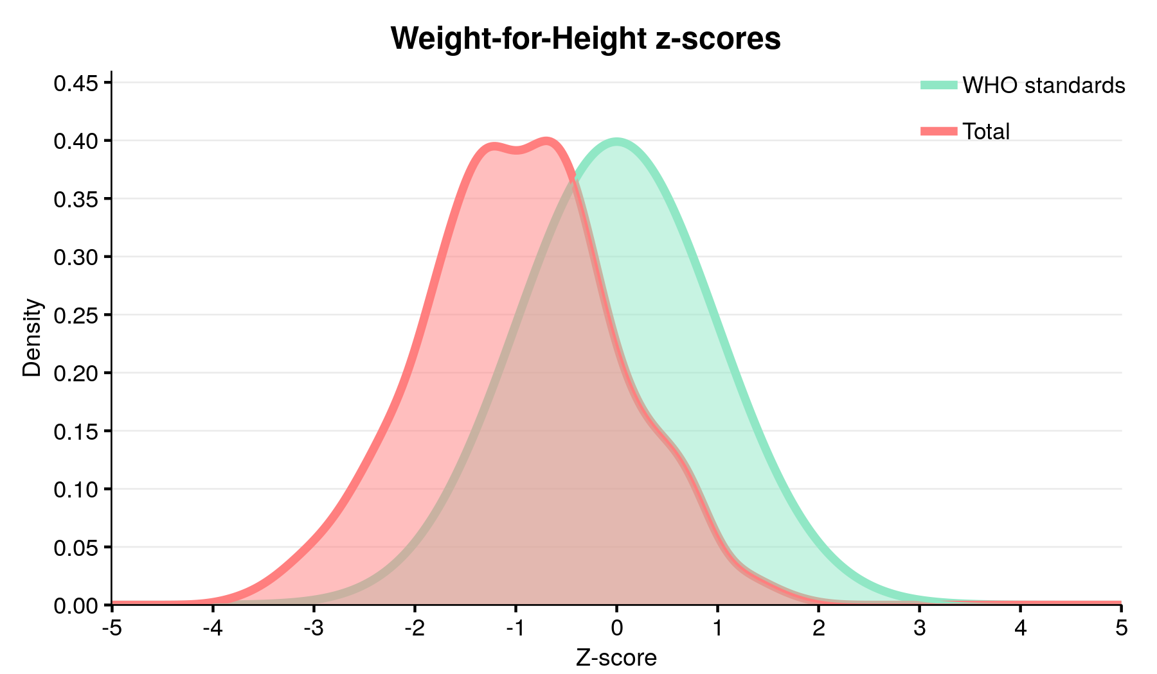
Figure 10-2: Mean WHZ by Age Group
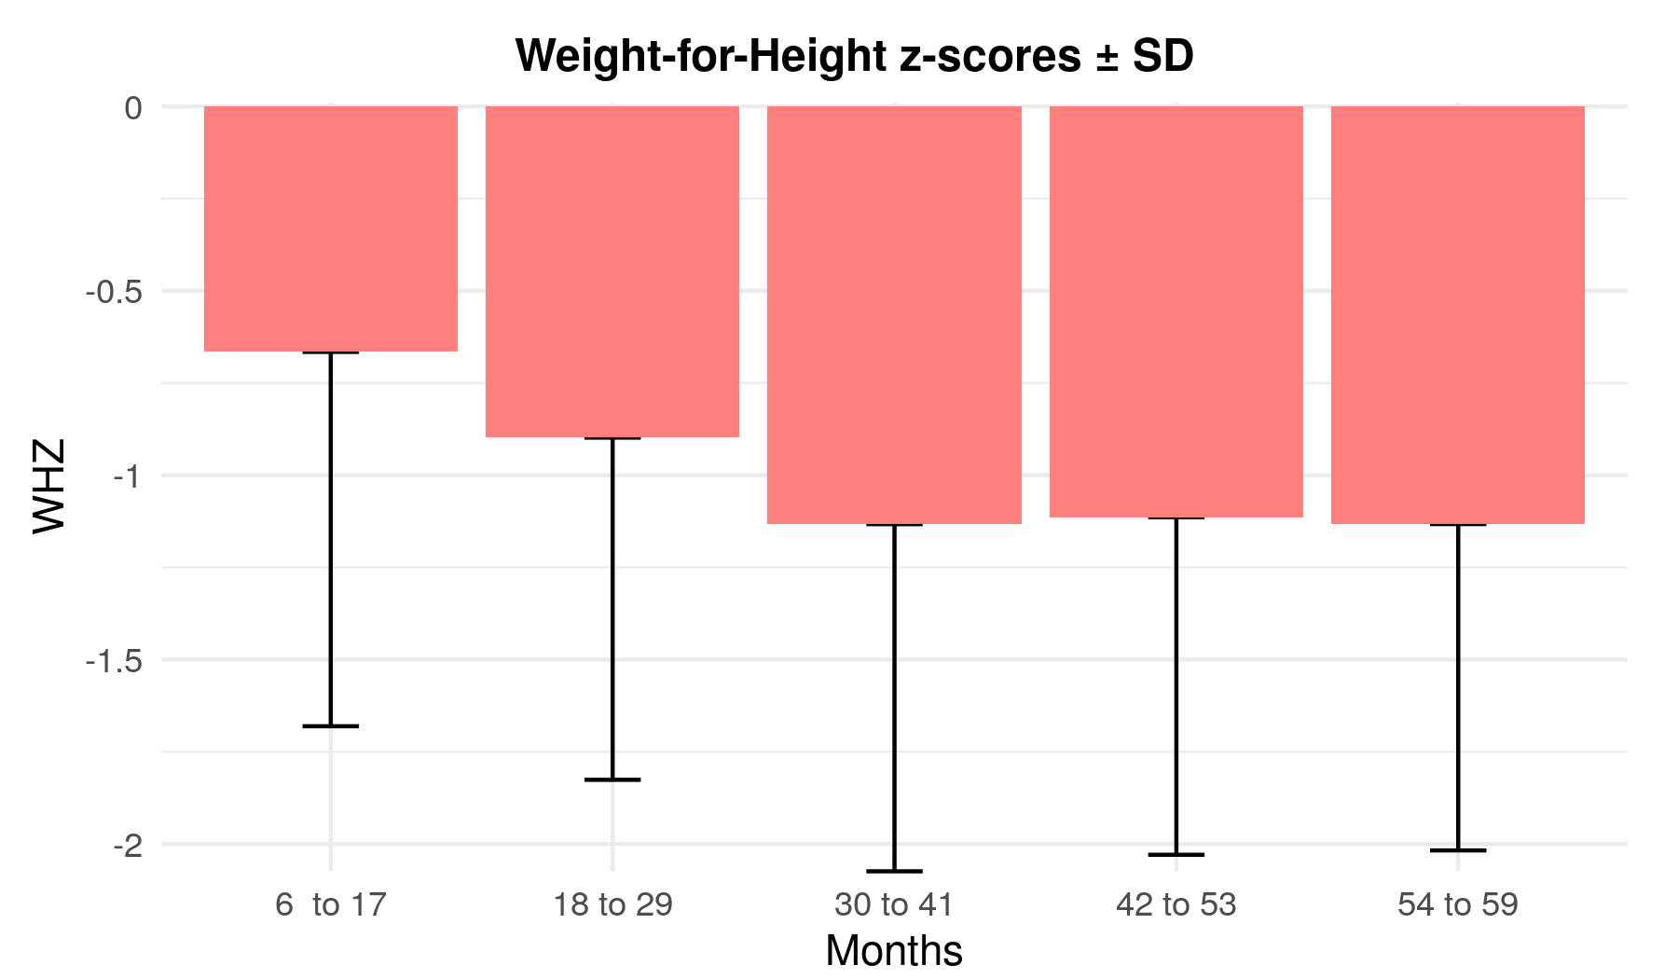
Table 10-14: Distribution of Severe Acute Malnutrition per Oedema among Children 6-59 months (SMART exclusions)
 | WHZ < -3 | WHZ ≥ -3
Presence of Oedema* | Marasmic kwashiorkor  0  (0.0%) | Kwashiorkor  0  (0.0%)
Absence of Oedema | Marasmic  10  (2.3%) | Not severely malnourished  434  (97.7%)
The prevalence of global acute malnutrition (GAM) and moderate acute malnutrition (MAM) among children aged 6-59 months, assessed using mid-upper arm circumference (MUAC), was examined. GAM, defined as MUAC < 125 mm and/or presence of oedema, was found in 1.8% of all children, with slightly higher prevalence among boys (2.1%) compared to girls (1.4%). Similarly, MAM, indicated by MUAC < 125 mm and ≥ 115 mm with no oedema, affected 1.1% of all children, with comparable rates between boys (1.3%) and girls (0.9%). Severe acute malnutrition (SAM), characterized by MUAC < 115 mm and/or presence of oedema, was observed in 0.7% of children, with a slightly higher prevalence among boys (0.9%) than girls (0.5%).
Table 10-15: Prevalence of acute malnutrition based on MUAC cut off's (and/or oedema) and by sex
Indicator | All  (N=447) | Boys  (N=233) | Girls  (N=214)
No malnutrition | (439) 98.2%  (96.3%, 99.2%) | (228) 97.9%  (94.1%, 99.2%) | (211) 98.6%  (95.7%, 99.6%)
Prevalence of global acute malnutrition (< 125 mm and/or oedema) | (8) 1.8%  (0.8%, 3.7%) | (5) 2.1%  (0.8%, 5.9%) | (3) 1.4%  (0.4%, 4.3%)
Prevalence of moderate acute malnutrition (< 125 and ≥ 115 mm, no oedema) | (5) 1.1%  (0.4%, 3.1%) | (3) 1.3%  (0.3%, 5.6%) | (2) 0.9%  (0.2%, 3.7%)
Prevalence of severe acute malnutrition (< 115 mm and/or oedema) | (3) 0.7%  (0.2%, 2.1%) | (2) 0.9%  (0.2%, 3.4%) | (1) 0.5%  (0.1%, 3.5%)
The prevalence of malnutrition indicators varied across different age cohorts. As the age cohorts progressed, the prevalence of malnutrition indicators generally decreased. Overall, there was a decline in the prevalence of malnutrition indicators as children aged.
Table 10-16: Prevalence of Acute Malnutrition per MUAC and/or Oedema by Severity and Age Group
Age (Months) | N | No malnutrition |  | GAM |  | MAM |  | SAM |  | Oedema
Age (Months) | N | n | % | n | % | n | % | n | % | n | %
6 to 17 | 97 | 91 | 93.8% | 6 | 6.2% | 3 | 3.1% | 3 | 3.1% | 0 | 0.0%
18 to 29 | 108 | 106 | 98.1% | 2 | 1.9% | 2 | 1.9% | 0 | 0.0% | 0 | 0.0%
30 to 41 | 105 | 105 | 100.0% | 0 | 0.0% | 0 | 0.0% | 0 | 0.0% | 0 | 0.0%
42 to 53 | 96 | 96 | 100.0% | 0 | 0.0% | 0 | 0.0% | 0 | 0.0% | 0 | 0.0%
54 to 59 | 41 | 41 | 100.0% | 0 | 0.0% | 0 | 0.0% | 0 | 0.0% | 0 | 0.0%
All | 447 | 439 | 98.2% | 8 | 1.8% | 5 | 1.1% | 3 | 0.7% | 0 | 0.0%
The table below presents the prevalence of combined global acute malnutrition (GAM) and severe acute malnutrition (SAM) among children, considering multiple anthropometric indicators including weight-for-height Z-score (WHZ), mid-upper arm circumference (MUAC), and presence of edema. Overall, the prevalence of combined GAM was 14.1%, while the prevalence of combined SAM was 2.7%. When disaggregated by gender, boys had a slightly higher prevalence of both combined GAM (16.3%) and combined SAM (3.4%) compared to girls, with prevalences of 11.7% and 1.9% respectively. Boys exhibited slightly higher rates than girls. Additionally, it underscores the importance of considering multiple indicators to accurately assess and address malnutrition in children.
Table 10-17: Prevalence of combined GAM and SAM based on WHZ and MUAC cut off's (and/or oedema) and by sex
Indicator | All  (N=447) | Boys  (N=233) | Girls  (N=214)
Prevalence of combined GAM (WHZ <-2 and/or MUAC < 125 mm and/or oedema) | (63) 14.1%  (10.9%, 18.0%) | (38) 16.3%  (12.2%, 21.4%) | (25) 11.7%  (7.3%, 18.3%)
Prevalence of combined SAM (WHZ <-2 and/or MUAC < 125 mm and/or oedema) | (12) 2.7%  (1.6%, 4.4%) | (8) 3.4%  (1.8%, 6.4%) | (4) 1.9%  (0.7%, 4.9%)
*With SMART or WHO flags a missing MUAC/WHZ or not plausible WHZ value is considered as normal when the other value is available

Table 10-18: Detailed number for combined GAM and SAM
 | Global Acute Malnutrition (GAM) |  | Severe Acute Malnutrition (SAM)
 | n | % | n | %
Oedema | 0 | 0.0%  (0%, 0%) | 0 | 0.0%  (0%, 0%)
Both | 6 | 1.3%  (0.6%, 2.9%) | 1 | 0.2%  (0.0%, 1.7%)
WHZ | 55 | 12.3%  (9.3%, 16.2%) | 9 | 2.0%  (1.1%, 3.7%)
MUAC | 2 | 0.4%  (0.1%, 1.8%) | 2 | 0.4%  (0.1%, 1.8%)
Total | 63 | 14.1%  (10.9%, 18.0%) | 12 | 2.7%  (1.6%, 4.4%)

Figure 10-3: Pie Chart of Proportion of Children with GAM by Indicator
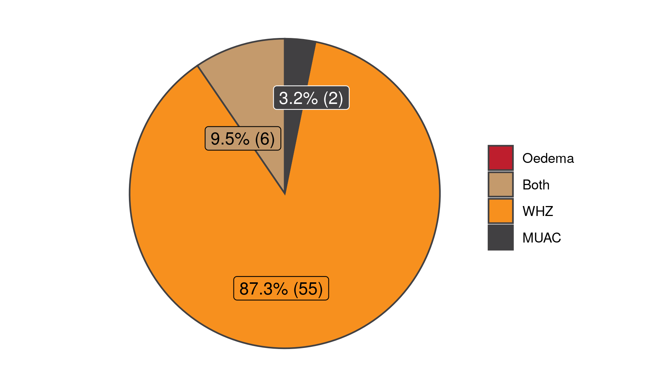
Figure 10-4: Pie Chart of Proportion of Children with SAM by Indicator
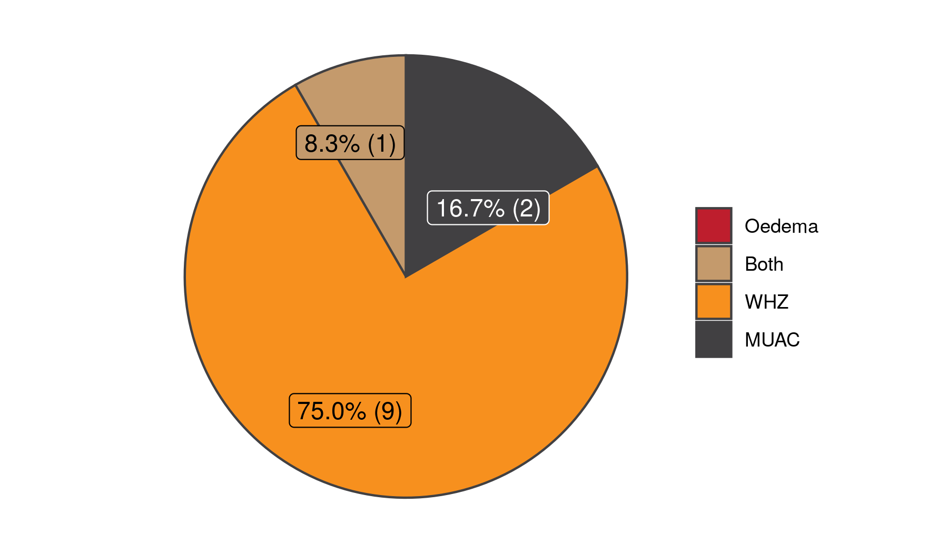

Prevalence of Chronic Malnutrition
The survey assessed chronic malnutrition, or stunting, among children aged 6-59 months using height-for-age Z-scores (HAZ). Results indicate a prevalence of 17.0% for chronic malnutrition, representing a slight increase from 15.5% in 2023. Stunting levels was classified as a medium based on WHO prevalence thresholds. When stratified by gender, boys exhibited a slightly higher prevalence of stunting at 19.4%, compared to 14.4% among girls.
Table 10-19: Prevalence of Chronic Malnutrition by HAZ by Severity and Sex among Children 6-59 months (SMART exclusions)
Indicator | All  (N=435) | Boys  (N=227) | Girls  (N=208)
Not stunted | (361) 83.0%  (77.9%, 87.1%) | (183) 80.6%  (74.5%, 85.6%) | (178) 85.6%  (78.9%, 90.4%)
Prevalence of chronic malnutrition (HAZ < -2 SD) | (74) 17.0%  (12.9%, 22.1%) | (44) 19.4%  (14.4%, 25.5%) | (30) 14.4%  (9.6%, 21.1%)
Prevalence of moderate chronic malnutrition (HAZ ≥ -3 to -2 SD) | (61) 14.0%  (10.6%, 18.3%) | (37) 16.3%  (12.1%, 21.6%) | (24) 11.5%  (7.2%, 18.0%)
Prevalence of severe chronic malnutrition (HAZ < -3 SD) | (13) 3.0%  (1.8%, 4.8%) | (7) 3.1%  (1.6%, 6.0%) | (6) 2.9%  (1.4%, 6.0%)

Table 10-20: Prevalence of Chronic Malnutrition per HAZ by Severity and Age Group (SMART exclusions)
Age (Months) | N | No stunting  (HAZ ≥ -2) |  | Stunting  (HAZ < -2) |  | Moderate stunting  (HAZ ≥ -3 to <-2) |  | Severe stunting  (HAZ < -3)
Age (Months) | N | n | % | n | % | n | % | n | %
6 to 17 | 90 | 74 | 82.2% | 16 | 17.8% | 13 | 14.4% | 3 | 3.3%
18 to 29 | 106 | 92 | 86.8% | 14 | 13.2% | 12 | 11.3% | 2 | 1.9%
30 to 41 | 102 | 84 | 82.4% | 18 | 17.6% | 16 | 15.7% | 2 | 2.0%
42 to 53 | 96 | 74 | 77.1% | 22 | 22.9% | 16 | 16.7% | 6 | 6.2%
54 to 59 | 41 | 37 | 90.2% | 4 | 9.8% | 4 | 9.8% | 0 | 0.0%
All | 435 | 361 | 83.0% | 74 | 17.0% | 61 | 14.0% | 13 | 3.0%

Figure 10-5: Distribution of HAZ Sample Compared to the WHO 2006 WHZ Reference Curve
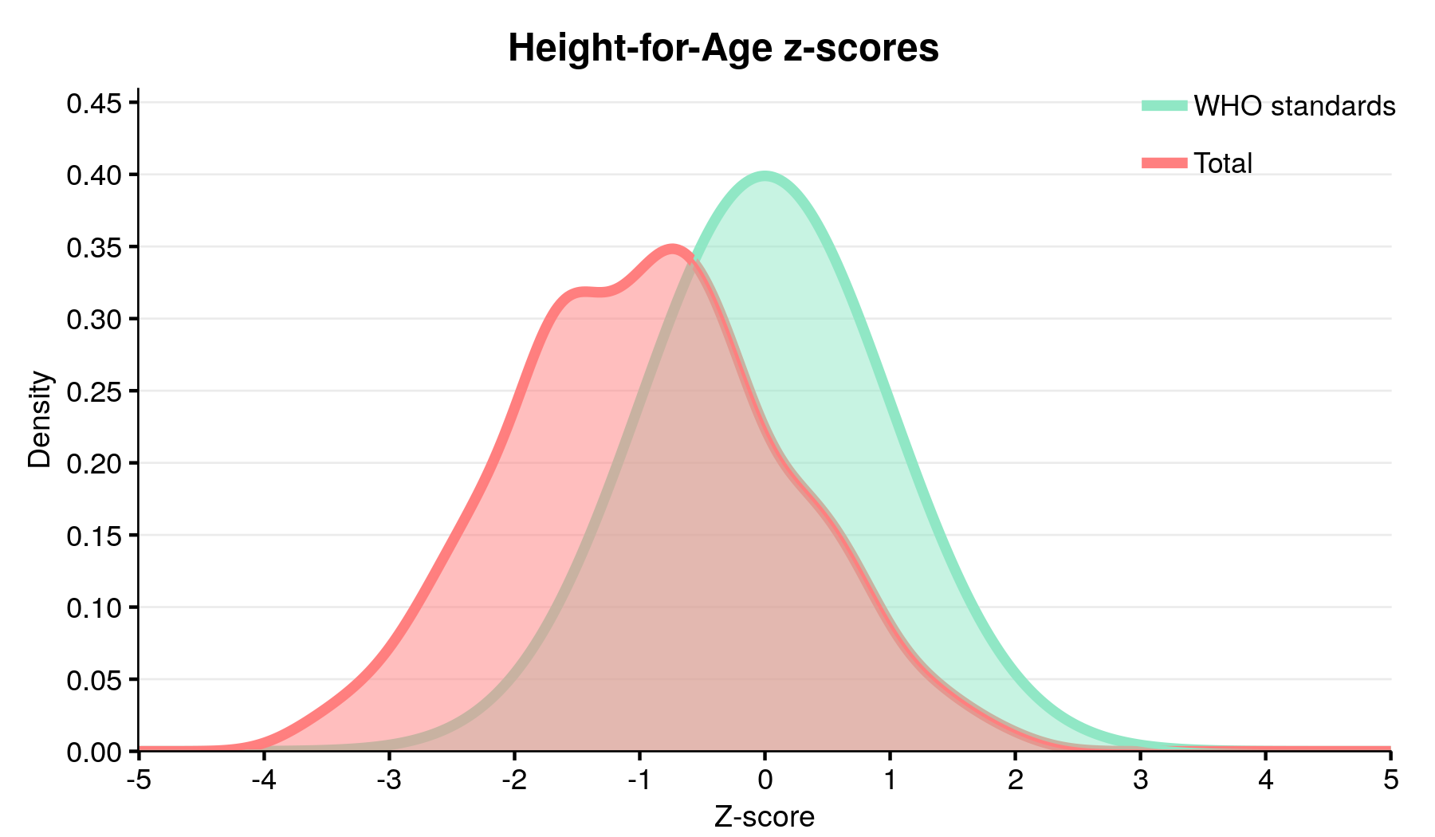
Figure 10-6: Mean HAZ by Age Group
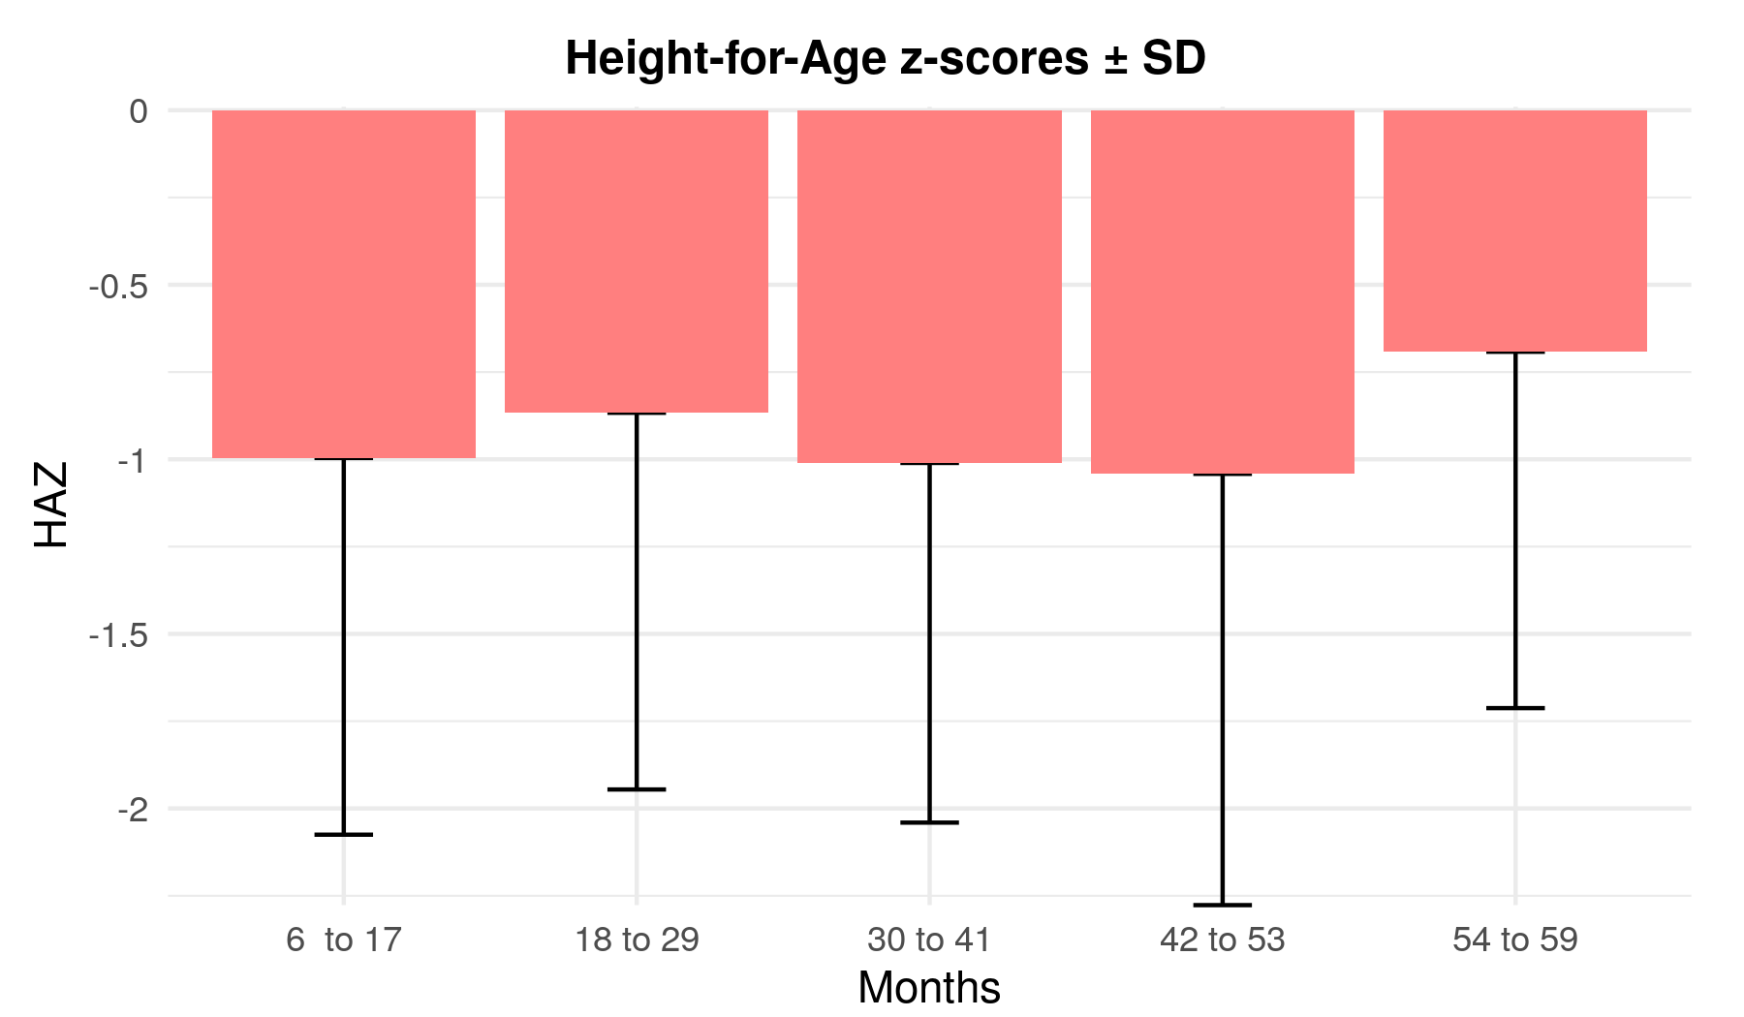

Prevalence of Underweight
The survey examined the prevalence of underweight among children aged 6-59 months using weight-for-age Z-scores (WAZ). Results revealed that 18.5% of children were classified as underweight, indicating a slight reduction from 20.0% in 2023. Among these, 14.4% experienced moderate underweight (WAZ between -3 and -2 SD), while 4.1% faced severe underweight (WAZ below -3 SD). The prevalence of underweight was slightly higher among boys, with 19.0% classified as underweight compared to 17.8% among girls.
Table 10-21: Prevalence of Underweight by WAZ by Severity and Sex among Children 6-59 months (SMART exclusions), WHO 2006 Reference
Indicator | All  (N=444) | Boys  (N=231) | Girls  (N=213)
Not underweight | (362) 81.5%  (77.6%, 84.9%) | (187) 81.0%  (75.5%, 85.4%) | (175) 82.2%  (75.1%, 87.5%)
Prevalence of underweight (WAZ < -2 SD) | (82) 18.5%  (15.1%, 22.4%) | (44) 19.0%  (14.6%, 24.5%) | (38) 17.8%  (12.5%, 24.9%)
Prevalence of moderate underweight (WAZ ≥ -3 to -2 SD) | (64) 14.4%  (11.7%, 17.6%) | (35) 15.2%  (11.2%, 20.2%) | (29) 13.6%  (9.4%, 19.3%)
Prevalence of severe underweight (WAZ < -3 SD) | (18) 4.1%  (2.4%, 6.7%) | (9) 3.9%  (2.2%, 6.8%) | (9) 4.2%  (2.0%, 8.7%)

Table 10-22: Prevalence of Underweight per WAZ by Severity and Age Group (SMART exclusions)
Age (Months) | N | Not underweight |  | Underweight  (WAZ < -2) |  | Moderate Underweight  (-3 ≤ WAZ < -2) |  | Severe Underweight  (WAZ < -3)
Age (Months) | N | n | % | n | % | n | % | n | %
6 to 17 | 95 | 80 | 84.2% | 15 | 15.8% | 12 | 12.6% | 3 | 3.2%
18 to 29 | 107 | 91 | 85.0% | 16 | 15.0% | 12 | 11.2% | 4 | 3.7%
30 to 41 | 105 | 82 | 78.1% | 23 | 21.9% | 18 | 17.1% | 5 | 4.8%
42 to 53 | 96 | 72 | 75.0% | 24 | 25.0% | 18 | 18.8% | 6 | 6.2%
54 to 59 | 41 | 37 | 90.2% | 4 | 9.8% | 4 | 9.8% | 0 | 0.0%
All | 444 | 362 | 81.5% | 82 | 18.5% | 64 | 14.4% | 18 | 4.1%

Figure 10-7: Distribution of WAZ Sample Compared to the WHO 2006 WHZ Reference Curve
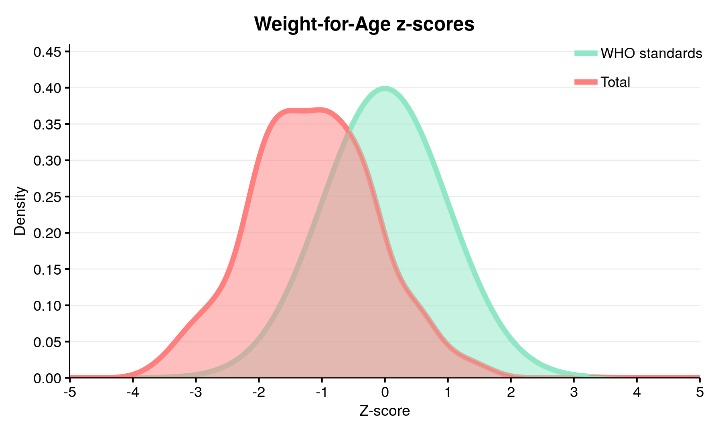
Figure 10-8: Mean WAZ by Age Group
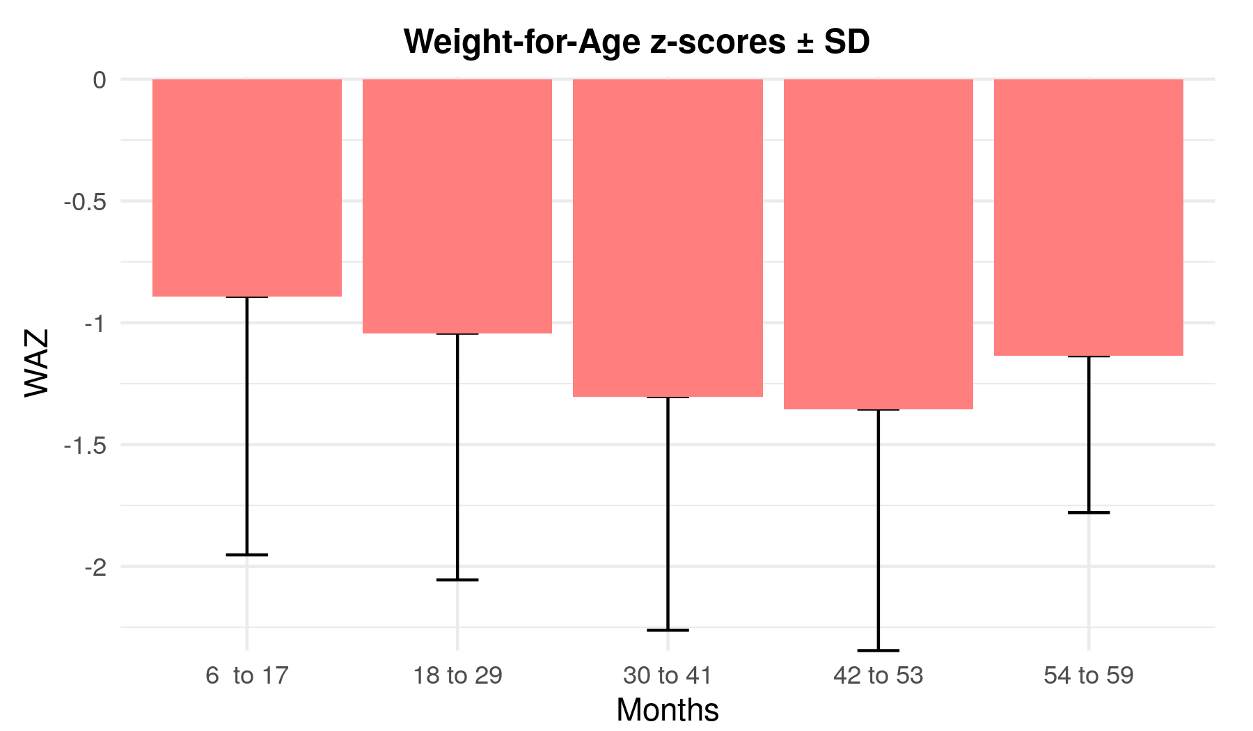

Other Indicator Results

Indicators at the Household Level

Food Security

Food Consumption Score (FCS)
The Food Consumption Score (FCS) serves as a comprehensive measure of household food security, encompassing dietary diversity, food frequency, and the nutritional significance of various food groups. Computed from 16 food categories collapsed into 8 groups, including cereals, pulses, vegetables, fruits, meats, dairy, sugars, and oils, the FCS is indicative of diet quality. By multiplying consumption frequency (up to 7 days) by assigned weight factors, households' FCS is determined. Classifications range from poor (score of 0 to 21) to borderline (21.5 to 35) to acceptable (35.5 and above). In this survey, 58.9% of households attained an acceptable FCS, while 4.7% scored poorly, and 36.4% fell into the borderline category. Notably, there was an increase in the proportion of households with acceptable FCS compared to 2023, where it stood at 38.9%.
Table 10-25: Average FCS*
Variable | Mean | 95% CI | Obs. | SD | Min | Max
FCS | 42.32 | (39.5, 45.1) | 621 | 17.08 | 11.5 | 112
* Maximum FCS is 112 (129.5 if specialized nutritious foods are included).

Table 10-26: Food Consumption Score by Category
Level | Freq. | Proportion | 95% CI
Acceptable (FCS > 35) | 366 | 58.9% | (51.7%, 65.8%)
Borderline (21.5 ≤ FCS ≤ 35) | 226 | 36.4% | (30.2%, 43.1%)
Poor (FCS ≤ 21) | 29 | 4.7% | (3.1%, 7.0%)
Total | 621 | 100.0% | -
* In countries where households have a high sugar and oil consumption (oil and sugar eaten on a daily basis - ~7 days per week), cut-off points of 28 (poor/borderline) and 42 (borderline/acceptable) are usually recommended.

Negative coping strategies and Reduced Coping Strategy Index (rCSI)
When livelihoods are negatively affected by a shock /crisis, households may adopt various mechanisms (strategies) which are not adopted in a normal day-to-day life, to cope with reduced or declining access to food. Reduced Coping Strategy Index (rCSI) is often used as a proxy indicator of household food insecurity. rCSI is based on a list of behaviors (coping strategies). It combines: (i) the frequency of each strategy (how many times each strategy was adopted?); and (ii) their (severity) (how serious is each strategy?) for households reporting food consumption problems. Higher CSI indicates a worse food security situation and vice versa.
For each coping strategy, the frequency score (0 to 7) is multiplied by the universal severity weight. The weighted frequency scores are summed up into one final score.
Table 10-27: Negative coping strategies used by the surveyed population over the past 7 days
Level | Freq. | Proportion | 95% CI
Rely on less preferred and/or less expensive foods | 504 | 80.9% | (74.9%, 85.8%)
Borrow food, or rely on help from a friend or relative | 412 | 66.0% | (58.4%, 72.9%)
Limit portion sizes at mealtime | 483 | 77.7% | (71.3%, 82.9%)
Reduce the number of meals eaten in a day | 469 | 75.2% | (68.5%, 80.8%)
Reduce consumption by adults so children could eat | 317 | 50.8% | (44.6%, 57.0%)
* The total will be over 100% as households may use several negative coping strategies.
Mean coping strategy index improved from 15.6 in 2023 to 12.71 in 2024.
Table 10-28: Average rCSI
Variable | Mean | 95% CI | Obs. | SD | Min | Max
Reduced Coping Strategy Index (rCSI) | 12.71 | (11.2, 14.2) | 621 | 8.82 | 0 | 50
* Maximum rCSI is 56

Household Hunger Scale (HHS)
The Household Hunger Scale (HHS) serves as a crucial indicator for measuring household hunger levels, assessing food deprivation experiences over the preceding 4 weeks or 30 days. By posing three specific questions, the HHS provides valuable insights into the prevalence of hunger, enabling monitoring of trends across countries and regions to gauge progress towards international development goals. Moreover, it facilitates the evaluation of food security situations, informing policy development and program implementation aimed at addressing food insecurity and hunger. The HHS also aids in the monitoring and assessment of the effectiveness of anti-hunger policies and programs, including those supported by specific donors across diverse cultural and geographic contexts. Additionally, it plays a vital role in early warning systems for nutrition and food security, as well as informing standardized classifications for food security and humanitarian phases.

Table 10-29: Median Household Hunger Score
Variable | Median | IQR | Min | Max
Household Hunger Scale | 1 | [0 - 2] | 0 | 3
* Maximum HHS is 6
Notably, in 2024, there was an increase in households with moderate hunger scores, rising from 37.8% in 2023 to 43.8%. Furthermore, there was a notable absence of severe household hunger scores in 2024.
Table 10-30: Household Hunger Score by Category
 |  | Freq. | Proportion | 95% CI
Little to no hunger in the household |  | 350 | 56.2% | (48.3%, 63.8%)
0 | HHS = 0 | 240 | 38.5% | (31.1%, 46.5%)
1 | HHS = 1 | 110 | 17.7% | (13.8%, 22.3%)
Moderate hunger in the household |  | 273 | 43.8% | (36.2%, 51.7%)
2 | HHS = 2 | 181 | 29.1% | (22.4%, 36.8%)
3 | HHS = 3 | 92 | 14.8% | (11.0%, 19.5%)
Severe hunger in the household |  | 0 | 0.0% | (0%, 0%)
4 | HHS = 4 | 0 | 0.0% | (0%, 0%)
5 | HHS = 5 | 0 | 0.0% | (0%, 0%)
6 | HHS = 6 | 0 | 0.0% | (0%, 0%)
Total |  | 623 | 100.0% | -

WASH

Access to safe/improved water for drinking and cooking
Access to safe and improved water sources for drinking and cooking is essential for ensuring the health and well-being of households. The proportion of households accessing water from protected sources remained stable, with 69.3% in 2024, similar to the figure of 69.2% recorded in 2023. However, there was a notable increase in the percentage of households accessing drinking water from water kiosks, rising from 5.3% in 2023 to 11.2% in 2024. Among the protected sources, the most common were public taps or standpipes, accounting for 27.4% of households, followed by piped connections to houses or neighboring houses at 23.0%. Conversely, a significant proportion of households, 30.7%, accessed water from un-protected or un-treated sources, including unprotected hand-dug wells (12.4%) and surface water such as lakes, ponds, dams, or rivers (15.4%).
Table 10-31: Water Quality (Adapt list to water sources available in the local setting)
 |  | Freq. | Proportion | 95% CI
Protected/treated |  | 432 | 69.3% | (55.1%, 80.7%)
1 | Public tap/standpipe | 171 | 27.4% | (18.0%, 39.5%)
2 | Handpumps/boreholes | 41 | 6.6% | (2.7%, 15.0%)
3 | Protected well | 7 | 1.1% | (0.3%, 4.8%)
4 | Water seller/kiosks | 70 | 11.2% | (5.0%, 23.3%)
5 | Piped connection to house (or neighbour's house) | 143 | 23.0% | (14.6%, 34.2%)
6 | Protected spring | 0 | 0.0% | (0%, 0%)
7 | Bottled water, water sachets | 0 | 0.0% | (0%, 0%)
8 | Tanker trucks | 0 | 0.0% | (0%, 0%)
Un-protected/un-treated |  | 191 | 30.7% | (19.3%, 44.9%)
9 | Unprotected hand-dug well | 77 | 12.4% | (5.6%, 25.2%)
10 | Surface water (lake, pond, dam, river) | 96 | 15.4% | (7.6%, 28.8%)
11 | Unprotected spring | 6 | 1.0% | (0.3%, 3.3%)
12 | Rain water collection | 4 | 0.6% | (0.1%, 3.1%)
96 | Other unprotected | 8 | 1.3% | (0.4%, 4.0%)
Unknown |  | 0 | 0.0% | (0%, 0%)
98 | Don't know | 0 | 0.0% | (0%, 0%)
Total |  | 623 | 100.0% | -

Table 10-32: Proportion of households practicing household water treatment
 |  | Freq. | Proportion | 95% CI
Yes |  | 215 | 34.5% | (26.8%, 43.1%)
1 | Yes, always treat it before drinking | 101 | 16.2% | (11.2%, 22.9%)
2 | Yes, sometimes treat it before drinking | 114 | 18.3% | (12.8%, 25.3%)
No |  | 409 | 65.5% | (56.9%, 73.2%)
3 | No, never treat it before drinking | 409 | 65.5% | (56.9%, 73.2%)
Other |  | 0 | 0.0% | (0%, 0%)
8 | Don't know | 0 | 0.0% | (0%, 0%)
Total |  | 624 | 100.0% | -
Household water treatment plays a crucial role in ensuring the safety and quality of drinking water, particularly in areas where access to treated water sources is limited. In the surveyed households, the prevalence of household water treatment increased significantly from 17.3% in 2023 to 31.9% in 2024. Among those households that reported treating their water, the most common method was the use of disinfection products, with 56.4% of households opting for this method. Aquatabs or water purification tablets were the most frequently used disinfection products, accounting for 41.2% of households. Boiling water was another prevalent method, with 35.3% of households choosing this option. This increase in household water treatment can be attributed to intensified hygiene promotion efforts and the distribution of water treatment chemicals at the community level. Despite this positive trend, a considerable proportion of households, 65.5%, reported never treating their water before drinking, highlighting the ongoing need for education and awareness campaigns to promote safe water practices and reduce the risk of waterborne diseases.
Table 10-33: Household Water Treatment Use
 |  | Freq. | Proportion | 95% CI
Let it stand and settle |  | 7 | 3.4% | (1.0%, 10.9%)
Boil it |  | 72 | 35.3% | (22.9%, 50.1%)
Expose it to sunlight |  | 1 | 0.5% | (0.1%, 3.8%)
Use disinfection products |  | 115 | 56.4% | (40.2%, 71.3%)
1 | Aquatabs/water purification tablets | 84 | 41.2% | (26.7%, 57.3%)
2 | Liquid chlorine | 4 | 2.0% | (0.4%, 9.1%)
3 | Powder or granular chlorine | 0 | 0.0% | (0%, 0%)
4 | PuR or Watermaker sachets | 27 | 13.2% | (5.1%, 30.0%)
6 | Other disinfection products | 0 | 0.0% | (0%, 0%)
Filter it |  | 0 | 0.0% | (0%, 0%)
1 | Biosand Filter | 0 | 0.0% | (0%, 0%)
2 | Ceramic Pot Filter | 0 | 0.0% | (0%, 0%)
3 | Candle Filter/Bucket Filter | 0 | 0.0% | (0%, 0%)
6 | Other filter system | 0 | 0.0% | (0%, 0%)
Other |  | 8 | 3.9% | (0.8%, 17.0%)
Don't know |  | 1 | 0.5% | (0.1%, 3.5%)
Total |  | 204 | 100.0% | -

Access to improved sanitation facilities
Access to improved sanitation facilities is a fundamental aspect of public health, ensuring the safe disposal of human waste and reducing the risk of waterborne diseases. In the surveyed households, 53.8% reported having access to improved sanitation facilities, indicating progress in sanitation infrastructure compared to previous years. Among these facilities, the most common were improved excreta disposal facilities, accounting for 20.7% of households, followed by communal toilets, utilized by 26.6% of households. However, despite these improvements, a significant proportion of households, 44.1%, still relied on unimproved sanitation facilities, such as open holes, bush, or pit latrines without slabs. This underscores the ongoing challenges in achieving universal access to adequate sanitation. Furthermore, the prevalence of open defecation increased from 24.4% in 2023 to 36.9% in 2024, attributed primarily to the destruction of sanitation facilities and the displacement of households due to floods caused by enhanced short rains. This highlights the need for concerted efforts to rebuild and improve sanitation infrastructure, particularly in areas prone to natural disasters, to ensure the health and well-being of communities.
Table 10-34: Safe Excreta Disposal (Adapt list to sanitation facilities available in the local setting)
 |  | Freq. | Proportion | 95% CI
Improved |  | 336 | 53.8% | (43.2%, 64.2%)
1 | An improved excreta disposal facility | 129 | 20.7% | (14.9%, 28.0%)
2 | A shared family toilet | 41 | 6.6% | (3.8%, 11.2%)
3 | A communal toilet | 166 | 26.6% | (19.8%, 34.8%)
Unimproved |  | 275 | 44.1% | (33.6%, 55.0%)
4 | An unimproved toilet | 275 | 44.1% | (33.6%, 55.0%)
Other |  | 13 | 2.1% | (0.7%, 6.0%)
98 | Don't know | 13 | 2.1% | (0.7%, 6.0%)
Total |  | 624 | 100.0% | -
Access to specific handwashing devices is a critical component of promoting proper hygiene practices, particularly in preventing the transmission of infectious diseases. In the surveyed households, 6.1% reported having access to a specific handwashing device. Among these households, the majority, comprising 79.5%, had a handwashing device containing water, while 56.4% had a device containing soap. Encouragingly, an equal proportion of households, also 56.4%, had a handwashing device equipped with both water and soap, indicating readiness for effective hand hygiene practices.
Table 10-35: Access to a Specific Handwashing Device
Level | Freq. | Proportion | 95% CI
Proportion of households with access to a specific handwashing device | 38 | 6.1% | (3.6%, 10.1%)
Proportion of households with a specific handwashing device containing water | 31 | 79.5% | (60.5%, 90.7%)
Proportion of households with a specific handwashing device containing soap | 22 | 56.4% | (35.9%, 74.9%)
Proportion of households with a specific handwashing device containing water and soap | 22 | 56.4% | (35.9%, 74.9%)
Regarding the types of handwashing devices, sinks with tap water were the most common, present in 50.0% of households with specific handwashing devices. Pouring devices and other types of handwashing devices were also reported, though less frequently. However, only a small proportion of households utilized buckets with taps, constituting 7.9%. These findings underscore the importance of promoting access to specific handwashing devices equipped with both water and soap, as well as the need to diversify handwashing device options to cater to different household preferences and contexts.
Table 10-36: Handwashing devices
Level | Freq. | Proportion | 95% CI
Sink with tap water | 19 | 50.0% | (30.7%, 69.3%)
Buckets with taps | 3 | 7.9% | (2.3%, 24.1%)
Pouring device | 13 | 34.2% | (18.8%, 53.9%)
Other | 3 | 7.9% | (2.1%, 25.4%)
Total | 38 | 100.0% | -

Access to a sufficient quantity of water
Access to a sufficient quantity of water is essential for meeting daily household needs, including drinking, cooking, and hygiene. The average quantity of water collected per person per day from protected or treated sources, regardless of container type, was 24.61 liters, ranging from 18.8 to 30.4 liters. When considering only protected containers, this average slightly decreased to 23.05 liters per person per day, indicating a reliable supply of water for domestic use.
Table 10-37: Water Quantity 1: Amount of Litres of Water Used Per Person Per Day
Variable | Mean | 95% CI | Obs. | SD | Min | Max
Average # L/p/d of domestic water collected at household level, from protected/treated sources with containers of any type | 24.61 | (18.8, 30.4) | 614 | 36.69 | 0 | 423.3
Average # L/p/d of domestic water collected at household level, from protected/treated sources with protected containers only | 23.05 | (17.4, 28.7) | 614 | 36.46 | 0 | 423.3
Despite this, there remains a significant portion of households with inadequate access to water, as 52.0% reported collecting less than 15 liters per person per day, according to the frequency distribution. However, nearly half of the households (48.0%) reported collecting 15 liters per person per day or more, suggesting that a substantial proportion of the population has access to an adequate quantity of water.
Table 10-38: Proportion of households that use domestic water collected from protected/treated sources with protected containers only
Level | Freq. | Proportion | 95% CI
≥ 15 lpppd | 295 | 48.0% | (37.9%, 58.4%)
< 15 lpppd | 319 | 52.0% | (41.6%, 62.1%)
Total | 614 | 100.0% | -

Indicators at individual level – Children 6-59 months

Nutrition and Health

Vitamin A Supplementation
The coverage of Vitamin A supplementation among children aged 6-59 months saw a slight increase from 78% in 2023 to 79.8% in 2024, although it remained below the set target of 80%. Among the households surveyed, 79.8% reported providing Vitamin A supplementation to their children, with 39.3% using a card system and 40.4% recalling the supplementation without documented evidence. Despite this progress, 20.2% of households did not provide Vitamin A supplementation to their children, indicating the need for continued efforts to reach the remaining portion of the population. This increase in coverage is attributed to ongoing integrated outreach efforts, including the incorporation of Vitamin A supplementation into mass screening programs and regular on-the-job training sessions focusing on the importance and administration of Vitamin A supplementation.
Table 10-39: Vitamin A supplementation coverage for children aged 6-59 months within the past 6 months
 |  | Freq. | Proportion | 95% CI
Supplementation |  | 359 | 79.8% | (71.0%, 86.4%)
1 | Yes, card | 177 | 39.3% | (31.3%, 47.9%)
2 | Yes, recall | 182 | 40.4% | (32.5%, 48.9%)
No supplementation |  | 91 | 20.2% | (13.6%, 29.0%)
3 | No or don't know | 91 | 20.2% | (13.6%, 29.0%)
Total |  | 450 | 100.0% | -

Deworming coverage
A significant proportion of households, comprising 70.4%, reported having undergone deworming. However, 29.6% of households did not participate in deworming, revealing a gap in coverage. The coverage falls below the target threshold of 80%, signaling the necessity for enhanced efforts to boost participation in deworming initiatives.
Table 10-40: Deworming coverage for children aged 12-59 months within the past 6 months*
Level | Freq. | Proportion | 95% CI
No | 111 | 29.6% | (22.0%, 38.5%)
Yes | 264 | 70.4% | (61.5%, 78.0%)
Total | 375 | 100.0% | -
* Note that this refers to large-scale campaigns done with mebendazole and/or albendazole.

Measles vaccination coverage
Measles vaccination coverage among children aged 9-23 months and 9-59 months demonstrates commendable rates, with both vaccination card and recall methods exceeding 90%. This suggests accessible healthcare services for children under five years old. However, a significant proportion of children who received measles vaccination was reported by recall rather than documented evidence, indicating a potential gap in record-keeping or awareness regarding vaccination cards.
Table 10-41: Measles vaccination coverage for children aged 9-59 months
 |  | Freq. | Proportion | 95% CI
Yes |  | 406 | 93.5% | (89.8%, 96.0%)
1 | Yes, card | 266 | 61.3% | (53.7%, 68.3%)
2 | Yes, recall | 140 | 32.3% | (25.9%, 39.4%)
No |  | 28 | 6.5% | (4.0%, 10.2%)
3 | No or don't know | 28 | 6.5% | (4.0%, 10.2%)
Total |  | 434 | 100.0% | -

Table 10-42: Measles vaccination coverage for children aged 9-23 months
 |  | Freq. | Proportion | 95% CI
Yes |  | 120 | 91.6% | (85.8%, 95.2%)
1 | Yes, card | 91 | 69.5% | (59.6%, 77.8%)
2 | Yes, recall | 29 | 22.1% | (14.8%, 31.8%)
No |  | 11 | 8.4% | (4.8%, 14.2%)
3 | No or don't know | 11 | 8.4% | (4.8%, 14.2%)
Total |  | 131 | 100.0% | -

Morbidity results and health-seeking behaviour
The prevalence of acute respiratory infection (ARI) symptoms, fever, and diarrhea among children aged 6-59 months in the two weeks preceding the survey was notable, with 5.8%, 36.4%, and 20.3% respectively reporting these symptoms. This marked increase from the previous year's rates of 8.6% for diarrhea and 9.4% for fever in 2023 indicates a concerning trend. Factors such as contaminated water sources and the destruction of sanitation facilities during floods could contribute to the higher prevalence of diarrhea and fever observed in 2024.
Table 10-43: Prevalence of ARI symptoms, fever and diarrhoea in the two weeks preceding the survey for children aged 6-59 months
Level | Freq. | Proportion | 95% CI
ARI symptoms* | 26 | 5.8% | (3.4%, 9.6%)
Fever | 164 | 36.4% | (29.5%, 44.0%)
Diarrhoea | 91 | 20.3% | (15.0%, 26.8%)
* Cough accompanied by short, rapid breathing which was chest related or with difficulty breathing which was chest related
The utilization of oral rehydration solution (ORS) and zinc tablets or syrup during diarrheal episodes among children aged 6-59 months was relatively high, with 72.5% and 71.4% of caregivers reporting their use, respectively. Interestingly, the combined use of both ORS and zinc was also reported by 71.4% of caregivers. However, there was a slight decrease in the management of diarrhea with ORS and zinc from 2023, dropping from 73% to 71% and 76% to 73%, respectively. This decline is concerning, especially in the context of a high prevalence of diarrhea at 20.3%. Possible reasons for this decrease include the displacement of households to areas lacking access to health facilities and the scaled-down integrated outreach efforts in certain locations within the County.
Table 10-44: ORS and zinc use during diarrhoea episode for children aged 6-59 months
Level | Freq. | Proportion | 95% CI
ORS use during diarrhoea episode | 66 | 72.5% | (63.4%, 80.1%)
Zinc tablet or syrup use during diarrhoea episode | 65 | 71.4% | (61.2%, 79.8%)
ORS and zinc tablet or syrup use during diarrhoea episode | 65 | 71.4% | (61.2%, 79.8%)
Health seeking behavior for children aged 6-59 months exhibiting symptoms of acute respiratory infections (ARI), fever, and diarrhea remained robust, with more than 80% of caregivers seeking advice or treatment from an appropriate health facility or provider. Specifically, 92.3% of children with ARI symptoms, 82.9% with fever, and 81.3% with diarrhea received attention from healthcare services. This indicates a positive trend in addressing childhood illnesses promptly and appropriately.
Table 10-45: Treatment for ARI symptoms, fever and diarrhoea for children aged 6-59 months
Level | Freq. | Proportion | 95% CI
Children with symptoms of ARI | 24 | 92.3% | (72.2%, 98.2%)
Children with fever | 136 | 82.9% | (72.5%, 89.9%)
Children with diarrhoea | 74 | 81.3% | (72.9%, 87.6%)
* Prevalences relate to whether advice or treatment was sought from a health facility/provider (excludes pharmacy, shop and traditional practitioners)

Infant and Young Child Feeding (IYCF) Practices
Infant and Young Child Feeding (IYCF) practices play a crucial role in shaping the health, development, and nutritional status of children under two years old, thereby influencing their overall well-being and survival. The survey conducted on IYCF practices focused on children aged 0-23 months within the sampled households. It revealed several key indicators of breastfeeding and complementary feeding practices. Most children, 97.1%, were breastfed at some point, demonstrating high rates of breastfeeding initiation. However, early initiation of breastfeeding within the first hour after birth was reported in 69.8% of cases, falling short of the optimal target. Similarly, exclusive breastfeeding for the first two days after birth was observed in 77.3% of cases. Among infants aged 0-5 months, 80.0% were exclusively breastfed, while 12.0% received mixed milk feeding. Furthermore, continued breastfeeding among children aged 12-23 months was prevalent at 72.7%. In terms of complementary feeding, the introduction of solid, semi-solid, or soft foods among children aged 6-8 months was reported in 68.8% of cases. However, achieving an acceptable diet remained challenging, with only 13.6% of children meeting the criteria for a minimum acceptable diet. Additionally, unhealthy dietary practices, such as sweet beverage consumption (40.8%) and zero vegetable or fruit consumption (42.2%), were prevalent among children aged 6-23 months. It is essential to interpret these results cautiously, considering the limitations in sample size, and use them as proxy indicators to guide future programming and assessments in IYCF.

Table 10-46: Prevalence of Infant and Young Child Feeding Practices Indicators
Indicator | Age range | Freq | Proportion | 95% CI
Breastfeeding Indicators
Ever breastfed | 0-23 months | 167 | 97.1% | (92.1%, 99.0%)
Early Initiation | 0-23 months | 120 | 69.8% | (59.1%, 78.6%)
Exclusively breastfed for the first 2 days after birth | 0-23 months | 133 | 77.3% | (66.9%, 85.2%)
Exclusive breastfeeding under 6 months | 0-5 months | 20 | 80.0% | (56.6%, 92.5%)
Mixed milk feeding under 6 months | 0-5 months | 3 | 12.0% | (4.1%, 30.3%)
Continued breastfeeding | 12-23 months | 72 | 72.7% | (62.9%, 80.8%)
Complementary Feeding Indicators
Introduction of solid, semi-solid or soft foods | 6-8 months | 11 | 68.8% | (38.4%, 88.6%)
Minimum dietary diversity | 6-23 months | 57 | 38.8% | (29.0%, 49.5%)
Minimum meal frequency | 6-23 months | 48 | 32.7% | (24.7%, 41.8%)
Minimum milk feeding frequency for non-breastfed children | 6-23 months | 15 | 46.9% | (29.1%, 65.5%)
Minimum acceptable diet | 6-23 months | 20 | 13.6% | (8.2%, 21.8%)
Egg and/or flesh food consumption | 6-23 months | 34 | 23.1% | (15.0%, 33.8%)
Sweet beverage consumption | 6-23 months | 60 | 40.8% | (29.9%, 52.7%)
Unhealthy food consumption | 6-23 months | 22 | 15.0% | (9.3%, 23.3%)
Zero vegetable or fruit consumption | 6-23 months | 62 | 42.2% | (29.5%, 56.0%)
Other Indicators
Bottle feeding | 0-23 months | 100 | 58.1% | (49.4%, 66.4%)

Indicators at individual level – Women 15-49 years
The survey included all the women of reproductive age (WRA) in the selected households for the assessment of maternal nutrition.

Physiological Status and Age
The physiological status of women of reproductive age (WRA) was assessed across different categories, including non-pregnant, non-lactating; pregnant; and lactating with infants under and over six months old. Among the surveyed population, 59.0% were classified as non-pregnant and non-lactating, 11.8% were pregnant, 31.4% were lactating with infants under six months, and 68.6% were lactating with infants over six months.
Table 10-47: Physiological status for women aged 15-49
Level | Freq. | Proportion | 95% CI
Non-pregnant, non-lactating | 329 | 59.0% | (53.7%, 64.0%)
Pregnant | 66 | 11.8% | (8.4%, 16.3%)
Lactating with an infant less than 6 months | 54 | 31.4% | (23.3%, 40.8%)
Lactating with an infant greater than 6 months | 118 | 68.6% | (59.2%, 76.7%)
The average age of individuals surveyed was 29.28 years. The youngest participant was 15 years old, while the oldest was 49 years old. Overall, the dataset comprised 570 observations, providing a diverse representation of age groups within the surveyed population.
Table 10-48: Women's Age (all women aged 15-49)
Variable | Mean | 95% CI | Obs. | SD | Min | Max
Age | 29.28 | (28.6, 30.0) | 570 | 8.43 | 15 | 49

MUAC in women
Among non-pregnant, non-lactating women aged 15-49, the prevalence of mid-upper arm circumference (MUAC) malnutrition was assessed. The data revealed that 4.3% of women were malnourished (had a MUAC measurement less than 210mm). Conversely, the majority, comprising 95.7% of women, had a MUAC measurement of 210mm or greater, indicating no malnutrition. Additionally, when considering a slightly higher MUAC threshold of less than 230mm, the prevalence of malnutrition increased to 22.8%, with 77.2% of women showing no signs of malnutrition.
Among non-pregnant, non-lactating women aged 15-49, the prevalence of mid-upper arm circumference (MUAC) malnutrition was assessed. The data revealed that 4.3% of women fell into the malnourished category, with a MUAC measurement less than 210mm. Additionally, when considering those at risk, with a MUAC measurement between 210mm and less than 230mm, the prevalence of malnutrition increased to 22.8%.
Table 10-49: Prevalence of MUAC Malnutrition in Non-Pregnant, Non-Lactating Women (Aged 15-49)
Level | Freq. | Proportion | 95% CI
Prevalence of MUAC < 210mm | 14 | 4.3% | (2.4%, 7.7%)
No malnutrition (MUAC ≥ 210mm) | 310 | 95.7% | (92.3%, 97.6%)
Prevalence of MUAC < 230mm | 74 | 22.8% | (18.2%, 28.3%)
No malnutrition (MUAC ≥ 230mm) | 250 | 77.2% | (71.7%, 81.8%)
The prevalence of mid-upper arm circumference (MUAC) malnutrition among pregnant women and lactating women with infants less than 6 months old was assessed using predefined thresholds. The data revealed that 9.0% of women fell into the malnourished category, with a MUAC measurement less than 210mm.
Furthermore, when considering those at risk, with a MUAC measurement between 210mm and less than 230mm, the prevalence of malnutrition increased to 24.3%. This highlights the vulnerability of pregnant and lactating women to malnutrition, which can have significant implications for maternal and child health outcomes.
Table 10-50: Prevalence of MUAC Malnutrition in Pregnant Women and Lactating Women with an Infant Less Than 6 Months
Level | Freq. | Proportion | 95% CI
Prevalence of MUAC < 210mm | 10 | 9.0% | (4.8%, 16.3%)
No malnutrition (MUAC ≥ 210mm) | 101 | 91.0% | (83.7%, 95.2%)
Prevalence of MUAC < 230mm | 27 | 24.3% | (17.2%, 33.1%)
No malnutrition (MUAC ≥ 230mm) | 84 | 75.7% | (66.9%, 82.8%)

Minimum Dietary Diversity- Women (MDD-W)
The Minimum Dietary Diversity for Women (MDD-W) indicator measures the diversity of food groups consumed by women of reproductive age. In 2024, there was a notable improvement in the percentage of women consuming five or more food groups, rising from 9.7% in 2023 to 28.0%. This improvement is credited to the implementation of community-level Maternal, Infant, and Young Child Nutrition (MIYCN) interventions across more than 50% of the Community Units (CUs) in Isiolo County. Among the food groups, grains and white roots/tubers were the most commonly consumed, with 98.4% of women including them in their diets.
Table 10-51: Percent of consumption of food groups by WRA
Level |  |  | Freq. |  | Proportion | 95% CI
 | Grains, White Roots & Tubers | 552 |  | 98.40% |  |  | 97.4%, 99.4%
 | Legumes | 379 |  | 67.60% |  |  | 63.7%, 71.4%
 | Nuts & Seeds | 49 |  | 8.70% |  |  | 6.4%, 11.1%
 | Milk & dairy products | 208 |  | 37.10% |  |  | 33.1%, 41.1%
 | Meat Poultry & Fish | 174 |  | 31.00% |  |  | 27.2% 34.8%
 | Eggs | 52 |  | 9.30% |  |  | 6.9%, 11.7%
 | Dark Green Leafy Vegetables | 226 |  | 40.30% |  |  | 36.2%, 44.3%
 | Other Vitamin A Rich Fruits & Vegetables | 154 |  | 27.50% |  |  | 23.8%, 31.1%
 | Other vegetables | 211 |  | 37.60% |  |  | 33.6%, 41.6%
 | Other fruits | 131 |  | 23.40% |  |  | 19.9%, 26.9%

Discussion

Nutritional Status of the county
The nutritional status of Isiolo County, as revealed by the most recent survey conducted in February 2024, indicates a Global Acute Malnutrition (GAM) prevalence of 13.7% (with a 95% confidence interval of 10.6-17.7%) and a Severe Acute Malnutrition (SAM) prevalence of 2.3% (with a 95% confidence interval of 1.3-4%). According to the UNICEF/WHO 2018 classification of acute malnutrition, the GAM prevalence falls within the "high" category. Comparing these findings to the previous SMART survey conducted in 2023, which unveiled a GAM prevalence of 15.4%, suggests a slight improvement in the nutrition status of children in the county.
Further analysis reveals that the GAM prevalence by weight-for-height z-score (WHZ<-2SD) decreased slightly from 15.4% in 2023 to 13.7% in 2024, although this decrease was not statistically significant (p value=0.466). Similarly, the SAM prevalence by WHZ<-3SD decreased from 3.1% in 2023 to 2.3% in 2024, though this decrease was also not statistically significant (p=0.450).
This slight decrease in GAM and SAM prevalence could be attributed to various interventions implemented in the county. Heightened case finding and treatment at the community level through initiatives such as family Mid-Upper Arm Circumference (MUAC) screenings and mass screenings have likely contributed to early detection and management of malnutrition cases. Additionally, active case finding, and integrated medical outreaches have facilitated access to healthcare services for vulnerable populations. The implementation of cash transfer programs, which prioritize households with malnourished children, has also likely played a role in reducing malnutrition prevalence by improving households' purchasing power and access to nutritious foods.
Overall, while there has been some improvement in the nutritional status of children in Isiolo County, continued efforts and sustained interventions are necessary to further reduce malnutrition prevalence and ensure the well-being of the county's population.
Table 11-51: Prevalence of GAM by WHZ Comparing the 0-59 Month to the 6-59 Month Sample
Sample | GAM by WHZ |  | SAM by WHZ
Sample | % | 95% CI | % | 95% CI
Children 6-59 Months | 13.7% | (10.6%, 17.7%) | 2.3% | (1.3%, 4.0%)

Determinants of Malnutrition
The determinant of malnutrition in Isiolo County encompasses a range of immediate, underlying, and basic causes, each contributing to the prevalence of malnutrition among its population.
Immediate causes primarily stem from inadequate food consumption and diseases. Despite efforts to improve nutrition, significant proportions of the population fall short of meeting dietary diversity and meal frequency requirements, with only 38.8% meeting the Minimum Dietary Diversity (MDD) threshold and 32.7% meeting the Minimum Meal Frequency (MMF) threshold. Additionally, the prevalence of diseases such as diarrhoea (20.3%), malaria/fever (36.4%), and Acute Respiratory Infection (ARI) (5.8%) exacerbates malnutrition by affecting nutrient absorption and increasing metabolic demands.
Underlying causes further compound the issue, including food security dimensions, caring and feeding practices, and access to health services and environmental health. Acute food insecurity and reduced coping strategies indicate limited access to adequate food and essential non-food expenditures, contributing to malnutrition. Suboptimal breastfeeding practices, such as exclusive breastfeeding under six months (80%), and delayed introduction of complementary foods (68.8%), also contribute to nutritional deficiencies. Limited access to essential health services and poor environmental health further exacerbates the problem.
Basic causes, such as unusual shocks like floods, can disrupt food security, access to healthcare, and overall well-being, further worsening malnutrition.
The prospects for the coming months may vary depending on seasonal changes, environmental factors, and the effectiveness of interventions. Seasonal fluctuations, such as droughts or floods, may impact food availability and disease prevalence, affecting malnutrition rates. However, continued efforts to address underlying determinants and implement targeted interventions may mitigate the situation.
Vulnerable populations, including children, pregnant and lactating women, and marginalized communities, are worst affected by malnutrition due to their heightened susceptibility and limited access to resources and services.
Chronic determinants of malnutrition, such as poverty, inadequate healthcare infrastructure, lack of education, and environmental factors like poor sanitation and unsafe drinking water, perpetuate the cycle of malnutrition in the long term.
To address malnutrition comprehensively, the community recommended multi-sectoral approaches that prioritize improving food security, promoting optimal caring and feeding practices, enhancing access to healthcare services, and addressing environmental health issues. Community engagement, capacity-building initiatives, and collaboration between stakeholders are essential to implement sustainable solutions and improve the overall nutritional status of the population.
- A diagram to show the causal framework of malnutrition may be useful.

Additional Indicators
Provide a discussion for any additional indicators that were included in the survey.

Conclusion and Recommendations
In conclusion, the nutrition situation in Isiolo County reflects a complex interplay of immediate, underlying, and basic causes contributing to high levels of malnutrition among its population. Immediate causes such as inadequate food consumption and disease prevalence, compounded by underlying factors like food insecurity, suboptimal caring and feeding practices, and limited access to healthcare and environmental health services, underscore the severity of the situation. Moreover, chronic determinants such as poverty, inadequate infrastructure, and environmental challenges further exacerbate malnutrition, posing significant challenges to the well-being of the community.
The urgency of the response required is paramount, given the high prevalence of malnutrition and its adverse impact on health outcomes and overall development. Immediate action is warranted to address the acute determinants of malnutrition, including targeted interventions to improve food security, promote optimal breastfeeding and complementary feeding practices, enhance access to healthcare services, and address environmental health issues. These efforts should be complemented by medium to longer-term strategies focusing on addressing chronic determinants and building resilience within the community.

Overall, a concerted and multi-sectoral approach is needed to address the complex drivers of malnutrition in Isiolo County effectively. By prioritizing evidence-based interventions, strengthening health systems, and promoting community engagement, we can work towards improving nutritional outcomes and enhancing the well-being of the population.

SECTOR | SURVEY FINDINGS | SHORT TERM RECOMMENDATIONS | MEDIUM TO LONG TERM RECOMMENDATIONS | RESPONSIBLE
HEALTH AND NUTRITION | High GAM prevalence of 13.7% (slight decrease from 15.4% in 2023)  High underweight prevalence at 18.5% (slight decrease from 20% in 2023)  High stunting prevalence at 17% up from 15% in 2023 | Refresher training to CHPS on module 8 Nutrition; (Emphasis should be on IMAM including commodity management to ensure accountability at HH level by caregivers.  Community sensitization while targeting key community influencers/decision makers with messages to discourage commodity sharing at the Household level within our community health units (Chiefs, Village elders, sub-areas, opinion leaders).  Upscaling of IMAM services to new health facilities - Shambani Dispensary and Gotu Dispensary.  Strengthen family MUAC intervention for early detection and self-referral by caregivers and referral by Community Health Promoters to the health facilities for further assessment.  Harmonisation of Family MUAC reporting  tool and strengthening Family MUAC monitoring by CHAs and SCHSFP.  To address aid diversion; Advocate for procurement of prototype stores, conduct community sensitization on diversion/sale of commodities from health facilities.  Formation of Community Commodity Monitoring Committee from HFMC+CHC to monitor commodity management at the facility level.  Case conferencing to discuss with different stakeholders (caregiver, CHP, CHA, MOH staff, partners) on the different reasons for non-respondents and defaulters and come up with multi-sectoral solutions.  Adherence to SoPs while implementing health and nutrition interventions; for example, outreaches should ensure clean water is available for cleaning, toilet facility is near the site, handwashing station available.  Strengthen Social Behaviour Change approaches in all the nutrition interventions to ensure positive behaviour change across the community that promote good health and wellbeing. | Recruitment of additional Nutritionists to address human resource gaps at the health facilities.  Strengthen nutrition advocacy for increased funding for nutrition interventions.  Strengthen multi-sectoral collaboration between nutrition sensitive and specific programming.  Renovation of existing stores by putting grills in doors and windows for commodity security.  Specifically, construction/ renovation of stores at Lengurma, Mogore, Noloroi, Lafe and Dima Adho, Gubatu. Facilities to prioritise for renovation; Oldonyiro, Kipsing, Modogashe, Biliqo Marara, Eremet, Daaba, Bulesa, Saleti, | County Department of Health and partners
HEALTH AND NUTRITION | Vitamin A Supplementation for children 6-59 months (79.8%) and deworming coverage (70.4%) down from 72.5% in 2023. | Intensify Vitamin A supplementation and deworming during community activities like mass screening using the “screen and treat approach”.  Procurement of mother child booklet (MoH 216) to address documentation related issues.  Dissemination of Vitamin A strategies/guides to the health managers and workers  Strengthen routine supplementation by ensuring health workers take opportunities for VAS supplementation and deworm children coming to health facilities.  OJTs and mentorships on VAS targeting and monthly monitoring.  Sensitising the CHVs on referral of eligible children to health facilities for vitamin A supplementation. |  | County Department of Health and partners
HEALTH AND NUTRITION | Only 22.4% of the pregnant women start ANC within the first three months.  IFAS utilisation for >90 days at 53.7% | Health care workers/CHPs sensitization on Focussed Antenatal Care (FANC)  Awareness creation on the importance of early ANC visits at community level, facility levels.  Support supervision to CHPs during household visits.  Need to focus on pre-conception counselling.  Demand driven incentives to encourage early ANC visits.  Foster male involvement as means of reaching women on IFAS consumption.  Develop social behaviour messages targeting the community on IFAS.  Reach women in mother-to-mother support groups and other women groups with key IFAS messaging.  Sensitization on the importance of IFAS utilisation to pregnant mothers  Sensitize community on IFAS utilisation during community dialogue days/community conversations/baby friendly gatherings/Barazas |  | County Department of Health and partners
 | 15.3% of women were at risk of malnutrition with 9% of the women malnourished by MUAC | Conduct community level screening for malnutrition targeting PLW through mass screening and routine community screening.  Health education on dietary diversity and preparation of quality diets  Support in upscaling of BFCI to all CUs for adaptation of good feeding and care practices  Set up kitchen garden around water sources like boreholes, seasonal rivers, and water pans |  | County Department of Health and partners
WATER, HYGIENE AND SANITATION | Morbidity:  Prevalence of Diarrhoea and Fever increased from 8.6% and 9.4% in 2023 to 20.3% and 36.4% respectively in 2024.  Prevalence of ARI at 5.8%. Only 92.3%, 81.3% and 82.9% of children who were ill accessed health care for ARI, diarrhoea and fever.  Management of diarrhoea by Zinc and ORS decreased from 73% and 76% in 2023 to 71% and 73% in 2024 respectively despite high prevalence of diarrhoea of 20.3% | Ensure availability of medical supplies at the health facilities and outreach sites  Promote exclusive breastfeeding for U5- through mother-to-mother support groups.  Educate the community on exclusive breastfeeding through information, educational materials- SBCC.  Scale up hygiene promotion activities at the community.  Scale up of integrated medical outreaches in hard-to-reach areas  Capacity building of community health promoters on use of health promotion kit  Health Education on benefits of zinc supplementation  Restocking of Zinc supplements and ORS at the facility level. | Improving access to safe drinking water through construction of new water sources and rehabilitation of existing ones  Increased vaccination for rotavirus, typhoid, measles, influenza  Strengthen multi-sectoral collaboration between nutrition sensitive and specific programing  Construction and re-operationalization of non-functional health care facilities  Improving infrastructure access to health facilities  Increase Staffing in health facilities.  Improve supply chain management and distribution of drugs and supplements
 | Handwashing at four critical times;  At HH level at 13.0% down from 27.81% in 2023 with a notable decrease in handwashing after taking children to the toilet from 34.4% in 2023 to 19.4% in 2024. | Procure and distribute water treatment chemicals  Hygiene promotion on the importance of consumption of treated water including demonstration and installation of hand washing stations. at household level  Use of social marketing and SBCC i.e., biosand filters | Monitor and evaluate impact of hand washing interventions, hygiene behaviors and health outcomes.  Drilling of bore holes to access safe water.  Construction of more water pans  Lobby for a policy document on water users’ association to streamline the water management at community level to increase access. | County Department of Water and Partners  STAWI
 | 36.9% of HHs do not have any toilet facility while only 55.8% of HH using improved toilet facility.  Open defecation increased marginally from 24.4% in 2023 to 36.9% in 2024 | Upscale and adopt CLTS approach, retriggering, and re- energising CLTS villages.  Complementing CLTS with sanitation marketing to improve adoption of durable sanitation. | Targeted training of local artisans on construction of durable climate proof latrines  Evaluate the impact cost effectiveness of CLTS approach.  Development of a County sanitation policy  Development and roll-out of county sanitation road map
 | Only 31.9% of HHs treat water using different water treatment technologies.  Only 69.3% of HHs drink water from protected/treated sources | Provide access to affordable and effective household water treatment commodities.  Support establishment & maintenance of community-based water treatment systems.  Treatment of water at the main source | Support linkage with last mile vendors for the water treatment commodities.  Establish water safety plans in community managed water systems.  Monitor and evaluate the impact of household water treatment.
FOOD SECURITY AND LIVELIHOOD | Noted improvement in food consumption with proportion of households at poor food consumption reducing from 23.9% in 2023 to 5% in 2024 while proportion of households at acceptable food consumption score increased from 38.9% to 59.0%.  5% of HHs had Food consumption score at poor and 36% of HH at borderline  The rCSI high at 12.71  Increase in HHs with moderate hunger score from 37.8% in 2023 to 43.8% in 2024.  72% of women consumed <5 food groups | Promotion of Nutrition Education and Behaviour change through Trainings: Conduct workshops or seminars to educate households about nutrition, balanced diets, and healthy cooking methods. Empower them with knowledge on how to make the most out of limited resources to ensure adequate nutrition.  -Incorporate nutrition promotion and education around food and sustainable food systems that builds on existing local knowledge, attitudes and practices. Nutrition knowledge can enhance the impact of production and income in rural households, especially important for women and young children, and can increase demand for nutritious foods in the general population.  Promotion of Kitchen Gardens: Encourage households to start small kitchen gardens. Provide training on gardening techniques and distribute seeds or seedlings for vegetables and herbs that are easy to grow. This can supplement their food intake with fresh produce.  Facilitate production diversification and increase production of nutrient-dense crops and small-scale livestock (for example, horticultural products, legumes, livestock and fish at a small scale, underutilised crops, and biofortified crops). Diversified production systems are important to vulnerable producers to enable resilience to climate and price shocks, more diverse food consumption, reduction of seasonal food and income fluctuations, and greater and more gender-equitable income generation  Implementation of Agricultural Development Programs:  Implement agricultural development programs aimed at increasing food production and diversification. This can include providing access to improved seeds, fertilisers, and irrigation systems, as well as training in modern farming techniques to enhance productivity and resilience to climate change.  Promotion of Food Preservation Techniques and Value addition: Provide training on food preservation techniques such as drying, canning, and pickling. This helps households store surplus food for longer times and reduces food waste.  Encourage HouseHolds Kitchen Initiatives: Encourage the formation of common Household kitchens where households can pool resources and cook meals together, reducing the cost burden and ensuring access to nutritious meals.  Enhance Monitoring and Evaluation: Regularly monitor the impact of interventions through food consumption surveys and household assessments. Adjust strategies based on feedback and emerging needs.  Partnerships with NGOs and Government Agencies: Collaborate with non-governmental organisations (NGOs) and government agencies to leverage resources and expertise in implementing food security programs effectively.  Promotion of Food Diversity: Encourage households to diversify their food sources by consuming a variety of foods from different food groups to ensure they obtain essential nutrients. For example High Iron Rich Beans, OFSP, Fish, Darky leafy green vegetables and tradition vegetables and fruits  Enhance Nutrition Support Programs:  Launch targeted nutrition support programs for vulnerable groups, including Mother to mother support groups,  pregnant women, lactating mothers, infants, and young children. Provide  fortified food products, such as fortified cereals or micronutrient  supplements, to improve their nutritional intake. Promoting cooking demonstrations to enhance food acceptance and social behaviour change to certain foods to improve consumption of safe, healthy and nutritious foods. | Agricultural Development Programs:  Implement agricultural development programs aimed at increasing food production and diversification. This can include providing access to improved seeds, fertilizers, and irrigation systems, as well as training in modern farming techniques to enhance productivity and resilience to climate change. Introduction of Agri-food hubs that will promote long term self reliance and job creation to the communities involved.  Monitor dietary consumption and access to safe, diverse, and nutritious foods; The data could include food prices of diverse foods, and dietary consumption indicators for vulnerable groups.  Infrastructure Development: Invest in infrastructure development in rural areas, such as storage facilities, and market linkages. Improved infrastructure facilitates access to markets, reduces post-harvest losses, and enhances the overall efficiency of the food supply chain.  Empowerment of Women: Promote gender equality and empower women through initiatives that enhance their access to resources, education, and decision-making power within households and communities. Women play a crucial role in food production and household nutrition, and empowering them can lead to improved food security outcomes.  Enhance Community-Based Approaches: Foster community-based approaches to food security through the establishment of community gardens, cooperatives, and savings groups(VSLAs and SILC, CBOs). These initiatives encourage collective action, knowledge sharing, and resource pooling among community members to address food insecurity collectively.  Develop Climate Resilience Strategies: Develop climate resilience strategies to mitigate the impact of climate change on agriculture and food security. This can involve promoting drought-resistant crops, agroforestry practices, and water harvesting techniques to adapt to changing environmental conditions. Promoting of superior breeds and introduction of livestock production systems like feedlots.  Integrating Nutrition-Sensitive Agriculture: Integrate nutrition-sensitive agriculture practices into agricultural development programs to promote the production and consumption of diverse, nutrient-rich foods. This includes promoting the cultivation of fruits, vegetables, and legumes rich in essential vitamins and minerals and ensuring sustainability of the same.  Promotion of Education and Awareness Campaigns: Conduct education and awareness campaigns on nutrition, hygiene, and healthy cooking practices to promote social behaviour change at the household level. Empowering households with knowledge about balanced diets and good nutrition practices can improve food consumption scores over the long term.  Strengthen multi stakeholder platform for nutrition (MSP-N) ie health, environment, social protection, labor, water and sanitation, education, energy) and programmes, through joint strategies with common goals, to address concurrently the multiple underlying causes of malnutrition.  Sustainably Maintain and improve the natural resource base (water, soil, air, climate, biodiversity), critical to the livelihoods and resilience of vulnerable farmers and to sustainable food and nutrition security for all. Manage water resources in particular to reduce vector-borne illness and to ensure sustainable, safe household water sources.  Advocating for Policy Support and Advocacy: Advocate for supportive policies and investments in agriculture, nutrition, and social protection at the national and local levels. Policy support is essential for creating an enabling environment for sustainable food security interventions and ensuring their long-term impact.  Promoting and supporting the 4K Club Initiative and Young Farmers: Collaboration and partnerships between members of the 4K Club, Young Farmers, agricultural experts, policymakers, and community organisations can amplify efforts to improve food security and livelihoods. By pooling resources, expertise, and networks, stakeholders can implement scalable solutions that address root causes of food insecurity and create sustainable livelihood opportunities for vulnerable population.  Expand markets and market access for vulnerable groups, particularly for marketing nutritious foods or products vulnerable groups have a comparative advantage in producing. This can include innovative promotion (such as marketing based on nutrient content), value addition, access to price information, and farmer associations. | National Government-MOAL & F  Department of Agriculture-Isiolo county  World Food Program (WFP)  NDMA  NACONEK-School Feeding Program  Department of Health  ACF  Nawiri  SNV  World Vision  MId-P  We-World  VSF  LMS  ILRI  FAO  Research and Academic Institutions

Annexes
- Cluster Selection
Attach the cluster assignment that is being used for the survey.
Geographical Unit | Population Size | Cluster
Isiolo_Wabera_Acacia | 2,740 | 1
Garbatulla_Sericho_Adele | 384 | 2
Isiolo_Burat_Akadeli | 577
Isiolo_Ngaremara_Akunoit | 210
Isiolo_Burat_Anti-PoachingUnit | 117
Isiolo_Ngaremara_Aregae | 452
Isiolo_Ngaremara_Ariamawoi | 190
Isiolo_Ngaremara_Aroo | 350
Isiolo_Ngaremara_Atir | 353
Isiolo_Ngaremara_NgipisingeAkuinoit(IDPs) | 400
Isiolo_Ngaremara_AttanChini | 261 | 3
Isiolo_Ngaremara_Attanjuu | 448
Merti_Charri_Awarsitu'A&'B' | 259
Garbatulla_Sericho_Badana | 538
Merti_Cherab_Badanararo | 566
Isiolo_Oldonyiro_Baibor | 321
Garbatulla_Kinna_Barambate/BullaWara | 438
Merti_Charri_BilikoMarara1'A' | 100
Merti_Charri_BilikoMarara'B'1&2 | 180
Merti_Cherab_BiliqiA | 204 | 4
Merti_Cherab_BiliqiB | 314
Merti_Cherab_BiliqiC | 114
Garbatulla_Sericho_BiliqiNur | 570
Merti_Charri_Bisiq1 | 159
Merti_Charri_Bisiq2 | 240
Garbatulla_Garbatulla_BojiNorth | 586
Garbatulla_Garbatulla_BojiSouth | 246
Garbatulla_Kinna_BulaMnanda/Lesan(Barambate) | 220
Merti_Charri_BulesaBox1 | 544 | 5
Merti_Charri_BulesaBox2 | 480
Isiolo_Bulapesa_Bullabao | 1,062
Garbatulla_Kinna_BullaHatawi | 501
Garbatulla_Sericho_BullaJuu | 321
Garbatulla_Kinna_BullaJuu(Barambate) | 180
Isiolo_Bulapesa_Bullakati | 904 | 6
Garbatulla_Kinna_BullaMadina(Rahima)Modogashe | 253
Isiolo_Wabera_BullaNasie | 796
Garbatulla_Sericho_BullaNorth | 351
Garbatulla_Kinna_BullaNyoka/Rapsu | 105
Garbatulla_Sericho_BullaPunda(Modogashe) | 260
Isiolo_Bulapesa_BullaSafi | 2,866 | 7
Garbatulla_Kinna_BullaSafi(Barambate) | 404
Isiolo_Wabera_BullaShariff | 682 | 8
Garbatulla_Kinna_BullaTown | 609
Garbatulla_Kinna_BullaTown(Barambate) | 200
Isiolo_Bulapesa_BullaWaso | 872
Isiolo_Bulapesa_BullaZamani | 1,268 | 9
Garbatulla_Sericho_Central(Modogashe) | 491
Merti_Cherab_TownA(Bassa) | 767
Merti_Cherab_BiliqiWest | 354
Merti_Cherab_BiliqiEast | 224
Merti_Cherab_BiliqiSouth | 139
Merti_Cherab_BiliqiKonaNne | 106
Merti_Cherab_BiliqiHajiEddin | 78
Merti_Cherab_BiliqiGuracha | 146
Merti_Cherab_CentralANorth(Korbesa) | 186
Merti_Cherab_TownB(Bassa) | 476 | 10
Merti_Cherab_CentralBSouth(Korbesa) | 328
Garbatulla_Kinna_Charabdicha(Kinna) | 881
Isiolo_Wabera_Chechelesi'A' | 1,705 | 11
Isiolo_Wabera_Chechelesi'B' | 213
Isiolo_Ngaremara_Chokaa | 635
Isiolo_Ngaremara_ChumviNdagale | 221
Isiolo_Ngaremara_ChumviYare | 463
Isiolo_Ngaremara_DaabaCentre | 466
Isiolo_Ngaremara_DaabaJuu | 401
Garbatulla_Kinna_Darajani | 655 | 12
Garbatulla_Garbatulla_DemoA | 218
Garbatulla_Garbatulla_DemoB | 218
Garbatulla_Sericho_Didimtu | 319
Merti_Charri_Dimaadho1 | 288
Merti_Charri_Dimaadho2 | 200
Merti_Cherab_Dololodakiye | 373
Isiolo_Burat_DonyoSarge | 346
Garbatulla_Kinna_KinnaNagele(Tenne) | 250
Garbatulla_Kinna_Duse | 444 | 13
Isiolo_Ngaremara_Epiding | 303
Isiolo_Burat_Eremet | 318
Garbatulla_Sericho_Hagarsu | 1,150
Isiolo_Ngaremara_Gambela | 175
Isiolo_Burat_Game | 1,166 | 14
Garbatulla_Garbatulla_GarbatullaTown | 598
Merti_Charri_Goda'A' | 392
Merti_Charri_Goda'B' | 434
Merti_Cherab_GodhRupa | 200
Isiolo_Ngaremara_Gotu | 209
Garbatulla_Kinna_Gubadida | 432
Garbatulla_Sericho_GubatuKalkachaHiloble | 1,054 | 15
Merti_Cherab_GuyoSekena | 524
Garbatulla_Kinna_JamiaMosque | 673
Garbatulla_Kinna_JilloDima | 558
Merti_Cherab_KambiJuu | 734 | 16
Isiolo_Burat_KampiGarba | 1,011
Isiolo_Burat_KampiSheik | 329
Isiolo_Burat_KampiTurkana | 541
Isiolo_Burat_Nomads | 392
Isiolo_Oldonyiro_KampiyaJuu | 432 | 17
Isiolo_Bulapesa_KampiYaJuu | 4,368 | RC
Isiolo_Ngaremara_KampiZebra | 450
Isiolo_Wabera_Kariakor/Soweto | 897
Isiolo_Oldonyiro_Kawalash | 919 | 18
Isiolo_Oldonyiro_Kililio | 207
Isiolo_Burat_KilimaniLMD/Kilimani | 1,403
Garbatulla_Kinna_KinnaTown | 543
Isiolo_Oldonyiro_KipsingTownCenter | 582 | 19
Isiolo_Ngaremara_Kisile | 433
Isiolo_Ngaremara_Kisima | 143
Isiolo_Ngaremara_Kiwanja | 500
Isiolo_Wabera_KiwanjaNdege | 1,550 | RC
Garbatulla_Garbatulla_Kiwanjani | 463
Isiolo_Wabera_Kiwanjani(Isiolo) | 1,007
Garbatulla_Garbatulla_KombolaNorth | 326
Garbatulla_Garbatulla_KombolaSouth | 354
Garbatulla_Kinna_KoneKalo/BullaMpya/Rapsu | 299
Garbatulla_Garbatulla_Koropu/TownCenterA | 376 | 20
Garbatulla_Garbatulla_Koropu/TownCenterB | 532
Garbatulla_Kinna_KotichaA | 629
Garbatulla_Kinna_KotichaB | 556
Garbatulla_Kinna_KotichaC | 645
Isiolo_Bulapesa_Kulamawe(Isiolo) | 7,383 | 23, 22, 21
Merti_Charri_BulesaFirimbi | 228
Isiolo_Ngaremara_KWSComplex | 165
Isiolo_Oldonyiro_Labarisherik | 1,086
Merti_Cherab_Lafe | 308
Isiolo_Oldonyiro_LagaramaB | 250 | 24
Merti_Cherab_Lakole | 210
Garbatulla_Sericho_Sapansa | 1,268
Isiolo_Oldonyiro_Langaaman(Tuale) | 331
Isiolo_Burat_Lankailer | 420
Isiolo_Burat_Lauri | 490
Isiolo_Oldonyiro_Lekiji | 260 | 25
Isiolo_Oldonyiro_Lemorijo | 419
Isiolo_Oldonyiro_Lenguruma | 235
Isiolo_Oldonyiro_Lengwenyi | 500
Isiolo_Burat_Leparua | 772
Isiolo_Oldonyiro_Longaman | 267
Isiolo_Oldonyiro_Longopito | 668
Isiolo_Oldonyiro_Loruko | 182 | RC
Isiolo_Burat_Loruko | 125
Isiolo_Oldonyiro_Losira | 258
Isiolo_Burat_Lotiki | 194
Isiolo_Oldonyiro_Loturo | 316
Isiolo_Ngaremara_Lowangila | 514
Isiolo_Oldonyiro_Lowuai | 400
Isiolo_Oldonyiro_L'pusi(Kipsing) | 524
Isiolo_Oldonyiro_Lpuus(Tuale) | 284
Isiolo_Oldonyiro_Ltingai | 1,000 | 26
Isiolo_Ngaremara_L'Tungai | 180
Garbatulla_Garbatulla_M.Central | 294
Garbatulla_Garbatulla_M.Dathey | 493
Garbatulla_Garbatulla_M.Dollo/Bubisa | 566
Garbatulla_Garbatulla_M.Gabra(Gafarsa) | 344
Garbatulla_Garbatulla_M.Golicha | 451 | RC
Garbatulla_Garbatulla_M.Koddo | 438
Garbatulla_Garbatulla_M.Kunato/BulaMpya | 510
Garbatulla_Garbatulla_M.Malle | 357
Garbatulla_Garbatulla_M.Racha | 404
Isiolo_Bulapesa_Mabatini | 800
Isiolo_Burat_MacharKwota/Alamach | 266 | 27
Garbatulla_Kinna_Madina(Kinna) | 512
Isiolo_Ngaremara_Maendeleo | 400
Isiolo_Burat_MailiSaba | 806
Isiolo_Burat_Maili-Tano | 1,242 | RC
Isiolo_Burat_MaishaBora | 368
Garbatulla_Sericho_Makarim | 375
Merti_Cherab_MalkagallaTownC | 503
Merti_Cherab_MalkagallaTownA | 478
Merti_Cherab_MalkagallaTownB | 635
Merti_Cherab_Boji(Bassa) | 107
Merti_Cherab_ManyataSakuye | 250
Merti_Charri_ManyattaAfya1(Biliqo) | 280 | 28
Merti_Charri_ManyattaAfya2(Biliqo) | 400
Merti_Cherab_ManyattaDawa | 396
Merti_Cherab_ManyattaDuba | 682
Merti_Cherab_ManyattaFugicha | 1,258
Merti_Cherab_ManyattaFunan | 577 | 29
Merti_Cherab_ManyattaGanna | 1,153
Merti_Charri_ManyattaMosque(Biliqo) | 463
Garbatulla_Kinna_Manyatta(TownCentre) | 321
Isiolo_Bulapesa_Marille | 1,857 | 30
Merti_Cherab_MataArbaA | 524
Merti_Cherab_MataArbaB | 419
Garbatulla_Garbatulla_MatagariA | 380
Garbatulla_Garbatulla_MatagariB | 373 | 31
Isiolo_Oldonyiro_Matundai | 706
Garbatulla_Garbatulla_MilimaniDaawa | 320
Garbatulla_Garbatulla_MilimaniDarga | 524
Merti_Cherab_MlandaNoor | 367
Isiolo_Oldonyiro_MlimaChui | 534
Isiolo_Oldonyiro_MlimaTatu | 300
Isiolo_Oldonyiro_Mokori | 536 | 32
Merti_Charri_BulesaMosque1&2 | 540
Garbatulla_Garbatulla_MuchuroNorth | 234
Garbatulla_Garbatulla_MuchuroSouth | 310
Garbatulla_Sericho_Mulanda | 461
Isiolo_Wabera_MwangazaA | 315
Isiolo_Wabera_MwangazaC | 210
Isiolo_Wabera_Mwangaza/Kiwanjani'B'' | 262
Isiolo_Oldonyiro_Naingura | 547 | 33
Isiolo_Ngaremara_Nakupurat | 272
Isiolo_Oldonyiro_Namelok | 616
Isiolo_Oldonyiro_Nantundu/Greenhouse | 1,272
Isiolo_Oldonyiro_Narasha | 327
Isiolo_Burat_Nasuulu | 230 | 34
Isiolo_Oldonyiro_NdonyoElengela | 467
Isiolo_Burat_Ngaramata | 200
Isiolo_Burat_NgareNtare(Ntalabany) | 319
Isiolo_Burat_NgareNtareA | 144
Isiolo_Oldonyiro_NgareNtare | 312
Isiolo_Burat_Ngaresirkon | 568
Isiolo_Ngaremara_NgaremaraCenter | 614
Isiolo_Ngaremara_Ngaremara'B' | 1,005 | 35
Isiolo_Oldonyiro_Ngorika | 312
Isiolo_Oldonyiro_Noloroi | 254
Isiolo_Oldonyiro_Ntepes | 563
Garbatulla_Kinna_Odha | 661
Isiolo_Burat_Odha | 1,255 | 36
Isiolo_Oldonyiro_OldonyiroTown | 404
Isiolo_Burat_OllaBulle | 1,612
Isiolo_Burat_OllaAdhe | 522 | 37
Isiolo_Bulapesa_OllaJarole | 1,253
Merti_Charri_Orotin | 404
Isiolo_Wabera_OsmanDima | 520
Isiolo_Oldonyiro_Parkuruk | 644 | 38
Garbatulla_Garbatulla_Prison | 225
Isiolo_Oldonyiro_Puruta | 300
Garbatulla_Sericho_Qalqalcha | 627
Garbatulla_Kinna_Qurquchi | 736
Isiolo_Oldonyiro_Raap | 457
Garbatulla_Garbatulla_ManyattaRefugee | 310
Merti_Cherab_BadanaK | 202 | 39
Merti_Cherab_ShauriYakoA | 166
Merti_Cherab_ShauriYakoB | 160
Merti_Cherab_ShauriYakoC | 130
Merti_Cherab_ShauriYakoD | 151
Merti_Cherab_Rigga | 318
Isiolo_Oldonyiro_Rumate | 489
Merti_Cherab_Sakuye1 | 1,049
Merti_Cherab_Sakuye2 | 839 | 40
Merti_Cherab_Saleti(OllaGabra) | 194
Merti_Cherab_SaletiA | 201
Merti_Cherab_SaletiB | 197
Garbatulla_Sericho_SerichoCentral | 425
Garbatulla_Sericho_SerichoNorth | 611
Garbatulla_Sericho_SerichoSouth | 620
Isiolo_Burat_Shambani | 1,140 | 41
Garbatulla_Kinna_Shambole | 147
Merti_Cherab_Shambole | 944
Garbatulla_Kinna_ShauriYako(KulaMawe) | 710
Merti_Cherab_Shauriyako1 | 367 | 42
Merti_Cherab_Shauriyako2 | 388
Isiolo_Oldonyiro_Siangaun | 306
Merti_Charri_Skuli | 280
Isiolo_Burat_Slaughter | 587
Merti_Cherab_Tachefayo | 241
Merti_Charri_Taqwa | 300
Merti_Cherab_Taqwa | 150
Garbatulla_Kinna_Taqwa | 447
Isiolo_Burat_Taqwa | 556 | 43
Merti_Cherab_Kiwanjani(Merti) | 265
Merti_Cherab_Taqwa1 | 996
Merti_Cherab_Taqwa2 | 944
Isiolo_Bulapesa_Town | 1,505 | 44
Merti_Cherab_Town'A' | 891
Merti_Cherab_Town'B' | 786
Isiolo_Ngaremara_Tractor | 274 | 45
Isiolo_Oldonyiro_Tualle | 447
Isiolo_Wabera_Tuluroba | 5,249 | 46
Isiolo_Wabera_Wabera | 1,807 | 47
Merti_Charri_Walote | 339
Garbatulla_Garbatulla_Wayam | 300
Garbatulla_Kinna_Yaq-Barasadi | 414
If you reassigned clusters your justification for this will appear here:
<justificationClusterReassignment>
- Standardization Test Results
Table 12-52: Bias and Technical Error of Measurement (TEM) Results for Weight
 | No. of subjects | TEM | Bias | Bias relative to | Outcome (TEM) | Outcome (Bias)
Individual TEM (intra)
Observer 1 | 10 | 0.10 | 0.06 | Supervisor | TEM poor | Bias acceptable
Observer 2 | 10 | 0.12 | 0.04 | Supervisor | TEM poor | Bias acceptable
Observer 3 | 10 | 0.55 | 0.17 | Supervisor | TEM reject | Bias poor
Observer 4 | 3 | 0.88 | 1.30 | Supervisor | TEM reject | Bias reject
Observer 5 | 10 | 0.07 | 0.03 | Supervisor | TEM acceptable | Bias good
Observer 6 | 10 | 0.10 | 0.04 | Supervisor | TEM poor | Bias acceptable
Observer 7 | 10 | 0.11 | 0.04 | Supervisor | TEM poor | Bias acceptable
Observer 8 | 10 | 0.22 | -0.01 | Supervisor | TEM reject | Bias good
Observer 9 | 3 | 0.88 | 1.30 | Supervisor | TEM reject | Bias reject
Observer 10 | 3 | 0.88 | 1.30 | Supervisor | TEM reject | Bias reject
Observer 11 | 10 | 0.07 | 0.02 | Supervisor | TEM acceptable | Bias good
Observer 12 | 10 | 0.06 | 0.05 | Supervisor | TEM acceptable | Bias acceptable
Observer 13 | 2 | 1.63 | -0.60 | Supervisor | TEM reject | Bias reject
Observer 14 | 10 | 0.05 | 0.08 | Supervisor | TEM acceptable | Bias acceptable
Observer 15 | 10 | 0.10 | 0.05 | Supervisor | TEM acceptable | Bias acceptable
Supervisor 1 | 10 | 0.08 | -0.03 | Median | TEM acceptable | Bias good
Observer 16 | 3 | 4.80 | 3.05 | Supervisor | TEM reject | Bias reject
Observer 17 | 0 |  |  | Median
Observer 18 | 0 |  |  | Median
Observer 19 | 0 |  |  | Median
Observer 20 | 0 |  |  | Median
Observer 21 | 0 |  |  | Median
Team TEM (inter)
enum inter 1st | 16x10 | 0.45 |  |  | TEM reject
enum inter 2nd | 16x10 | 1.10 |  |  | TEM reject

Table 12-53: Bias and Technical Error of Measurement (TEM) Results for Height
 | No. of subjects | TEM | Bias | Bias relative to | Outcome (TEM) | Outcome (Bias)
Individual TEM (intra)
Observer 1 | 10 | 0.45 | 0.17 | Supervisor | TEM acceptable | Bias good
Observer 2 | 10 | 0.49 | -0.03 | Supervisor | TEM acceptable | Bias good
Observer 3 | 10 | 3.12 | 0.29 | Supervisor | TEM reject | Bias good
Observer 4 | 3 | 0.95 | 14.43 | Supervisor | TEM poor | Bias reject
Observer 5 | 10 | 0.29 | 0.06 | Supervisor | TEM good | Bias good
Observer 6 | 10 | 0.50 | 0.28 | Supervisor | TEM acceptable | Bias good
Observer 7 | 10 | 0.60 | 0.29 | Supervisor | TEM poor | Bias good
Observer 8 | 10 | 0.11 | -0.22 | Supervisor | TEM good | Bias good
Observer 9 | 3 | 0.95 | 14.43 | Supervisor | TEM poor | Bias reject
Observer 10 | 3 | 0.95 | 14.43 | Supervisor | TEM poor | Bias reject
Observer 11 | 10 | 0.35 | -0.03 | Supervisor | TEM good | Bias good
Observer 12 | 10 | 0.40 | -0.11 | Supervisor | TEM acceptable | Bias good
Observer 13 | 2 | 12.84 | 6.00 | Supervisor | TEM reject | Bias reject
Observer 14 | 10 | 0.08 | 0.09 | Supervisor | TEM good | Bias good
Observer 15 | 10 | 0.24 | 0.13 | Supervisor | TEM good | Bias good
Supervisor 1 | 10 | 0.43 | -0.09 | Median | TEM acceptable | Bias good
Observer 16 | 3 | 0.95 | 14.43 | Supervisor | TEM poor | Bias reject
Observer 17 | 0 |  |  | Median
Observer 18 | 0 |  |  | Median
Observer 19 | 0 |  |  | Median
Observer 20 | 0 |  |  | Median
Observer 21 | 0 |  |  | Median
Team TEM (inter)
enum inter 1st | 16x10 | 4.16 |  |  | TEM reject
enum inter 2nd | 16x10 | 3.99 |  |  | TEM reject

Table 12-54: Bias and Technical Error of Measurement (TEM) Results for MUAC
 | No. of subjects | TEM | Bias | Bias relative to | Outcome (TEM) | Outcome (Bias)
Individual TEM (intra)
Observer 1 | 10 | 1.88 | 1.05 | Median | TEM good | Bias acceptable
Observer 2 | 10 | 1.77 | 3.05 | Median | TEM good | Bias reject
Observer 3 | 10 | 2.16 | 1.05 | Median | TEM acceptable | Bias acceptable
Observer 4 | 3 | 1.53 | -18.17 | Median | TEM good | Bias reject
Observer 5 | 10 | 1.18 | -0.40 | Median | TEM good | Bias good
Observer 6 | 10 | 30.42 | -6.10 | Median | TEM reject | Bias reject
Observer 7 | 10 | 1.82 | 1.40 | Median | TEM good | Bias acceptable
Observer 8 | 10 | 0.89 | -4.40 | Median | TEM good | Bias reject
Observer 9 | 3 | 1.53 | -18.17 | Median | TEM good | Bias reject
Observer 10 | 3 | 1.53 | -18.17 | Median | TEM good | Bias reject
Observer 11 | 10 | 1.34 | 0.60 | Median | TEM good | Bias good
Observer 12 | 10 | 29.24 | -5.87 | Median | TEM reject | Bias reject
Observer 13 | 2 | 4.03 | -25.00 | Median | TEM reject | Bias reject
Observer 14 | 10 | 0.32 | 0.40 | Median | TEM good | Bias good
Observer 15 | 10 | 4.53 | 1.35 | Median | TEM reject | Bias acceptable
Supervisor 1 | 10 | 4.69 | -2.05 | Median | TEM reject | Bias poor
Observer 16 | 3 | 1.53 | -18.17 | Median | TEM good | Bias reject
Observer 17 | 0 |  |  | Median
Observer 18 | 0 |  |  | Median
Observer 19 | 0 |  |  | Median
Observer 20 | 0 |  |  | Median
Observer 21 | 0 |  |  | Median
Team TEM (inter)
enum inter 1st | 16x10 | 12.09 |  |  | TEM reject
enum inter 2nd | 16x10 | 13.92 |  |  | TEM reject
- Plausibility Check
Attach the plausibility check here.
Table 12-55: Anthropometry Data Quality Snapshot
Component | Value | Score | Outcome
Flagged data | 0.7% | 0 | Excellent
Overall Sex ratio | p=0.370 | 0 | Excellent
Age ratio(6-29 vs 30-59) | p=0.947 | 0 | Excellent
Dig pref score – weight | 4 | 0 | Excellent
Dig pref score – height | 6 | 0 | Excellent
Dig pref score – MUAC | 4 | 0 | Excellent
Standard Dev WHZ | 0.96 | 0 | Excellent
Skewness WHZ | -0.02 | 0 | Excellent
Kurtosis WHZ | -0.12 | 0 | Excellent
Poisson dist WHZ-2 | p=0.081 | 0 | Excellent
OVERALL SCORE WHZ = |  | 0 | Excellent
- Integrated Questionnaire
- Map of Area
Include a map of the survey area here.
Figure 12-9: Survey Area

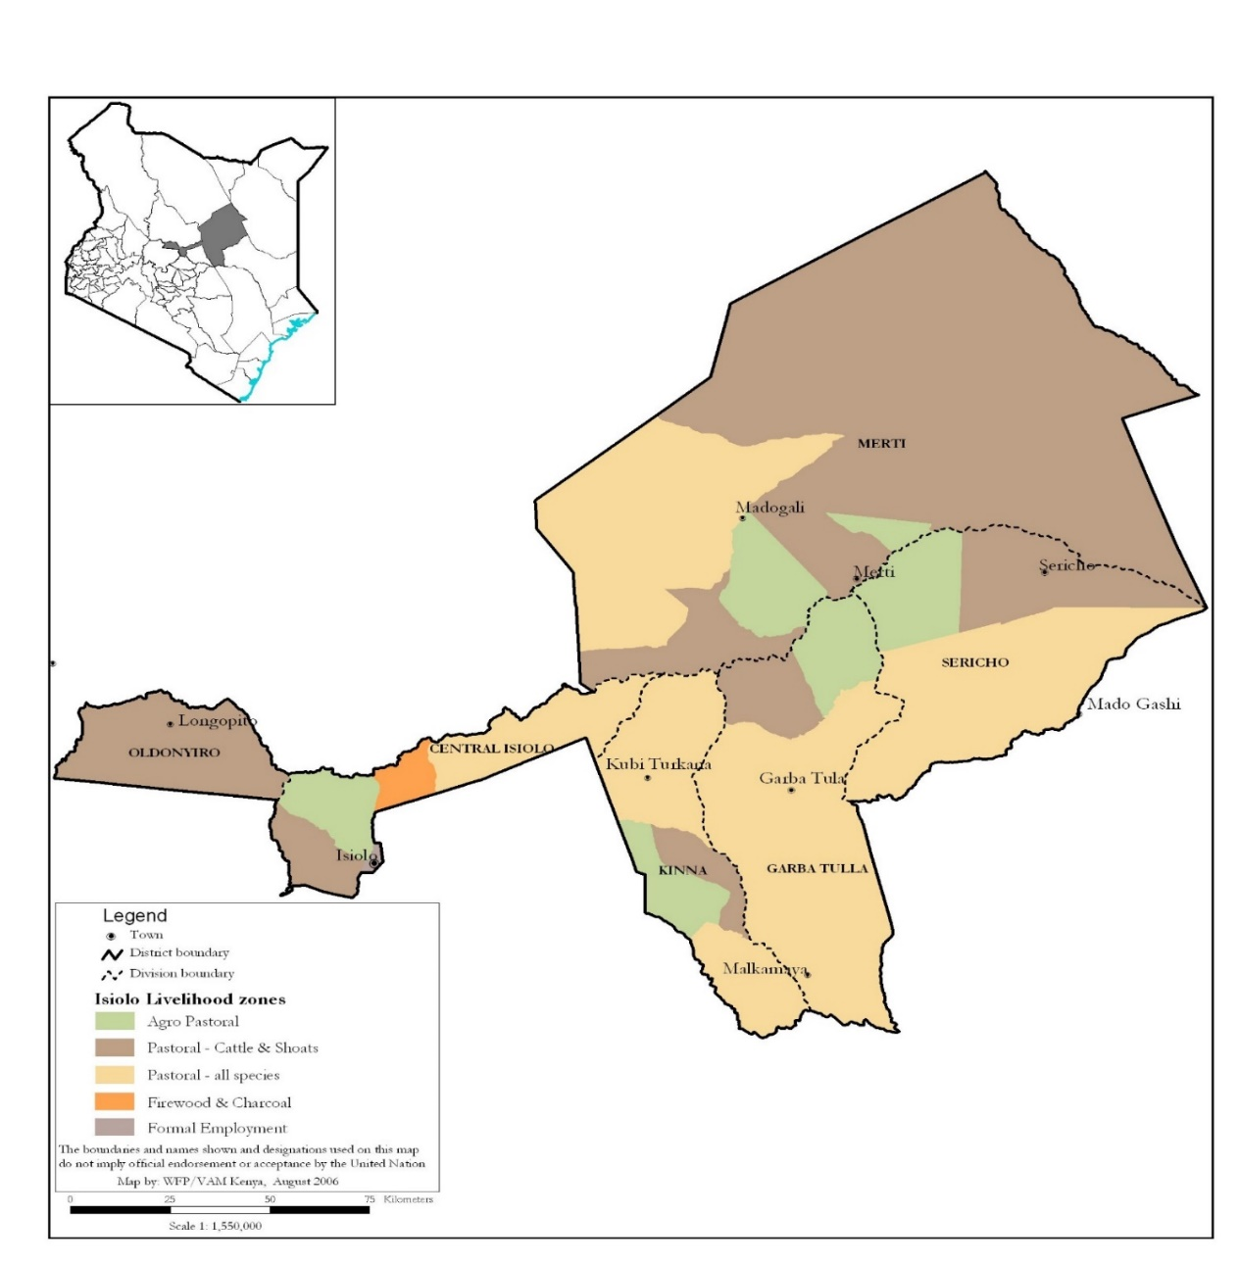
References
List your references here.

KNBS, Nov 2021
Daniel Maxwell, Richard Caldwell. The Coping Strategies Index: Field Methods Manual 2nd Edition, January 2008.
Ballard, Terri; Coates, Jennifer; Swindale, Anne; and Deitchler, Megan. Household Hunger Scale: Indicator Definition and Measurement Guide. Washington, DC: Food and Nutrition Technical Assistance II Project, FHI 360, August 2011.
Calculation and use of the food consumption score in food security analysis, UNWFP, 2008.
World Health Organization & United Nations Children's Fund (‎UNICEF)‎. (‎2021)‎. Indicators for assessing infant and young child feeding practices: definitions and measurement methods. World Health Organization.
WFP 2008. Coping Strategies Index: Field Methods Manual

